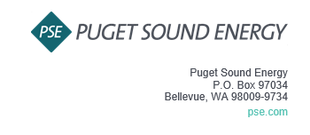
Notice of Customer Meeting for the 2023 PSE OATT Formula Rate Annual Update
Puget Sound Energy, Inc. (PSE) invites you to attend PSE’s Customer Meeting for the 2023 Annual Update to the PSE OATT Formula Rate. The Customer Meeting is an additional opportunity for Interested Parties to obtain information about the Annual Update.
The Customer Meeting is scheduled for July 12th, 2023 at 10:30 am PST. The meeting will be held via Microsoft Teams. The Teams information is as follows (Cntl+Click to follow the link):
Join on your computer, mobile app or room device
Click here to join the meeting
Meeting ID: 235 626 305 443
Passcode: NxxKGA
Download Teams | Join on the web
Or call in (audio only)
+1 323-484-5815,,746667564# United States, Los Angeles
Phone Conference ID: 746 667 564#
Find a local number | Reset PIN

If you have any questions, please contact Lynn Dillender at lynn.dillender@pse.com.
Sincerely,
Puget Sound Energy, Inc.

Lynn Dillender
Regulatory Compliance Consultant

