2020 RFP for Demand Response Programs

*August 14, 2020*

**

2020 Request for Proposals (RFP)

Technology and Implementation Services

In support of

Puget Sound Energy (PSE)  
Demand Response (DR) Program

|  |  |  |
| --- | --- | --- |
| Date | Milestone | |
| May 4, 2020 | Draft RFP filed with WUTC | |
| July 6, 2020 | Public comment period closes | |
| August 3, 2020 | WUTC expected to approve PSE's Demand Response RFP | |
| August 14, 2020 | PSE releases final RFP solicitation | |
| August 21, 2020 | | Intent to Bid Forms and Mutual Confidentiality Agreements due to PSE |
| September 4, 2020 | Offers due to PSE | |
| Q1 2021 | PSE selects final short list, notifies respondents | |

PSE reserves the right to reject any and all proposals. This RFP does not constitute an order or any obligation on the part of PSE. PSE is not liable for any costs associated with the preparation of Bidders' proposals, or for any other costs incurred by Bidders prior to the execution of a contract or purchase order.

**Table of Contents**

1 Summary of RFP 1

2 Background and DR Resource Requirements 3

PSE Background 3

2.1 Resource Need 3

2.2 DR Resource Objectives and Bidder Solution Requirements 6

3 Scope of Work 7

3.1 Roles and Responsibilities 7

3.2 Performance Goals 12

4 Technical Proposal 14

4.1 Technology Products and Related Services 15

4.2 Implementation Services 20

4.3 Project Management 24

5 Bidder Information and Qualifications 26

6 Proposal Format and Bidder Instructions 28

6.1 Bidder Selection Process 29

7 RFP and Bid Procedures 30

7.1 RFP Schedule 30

7.2 Intent to Bid 30

7.3 Questions and Communications 31

7.4 Submission of Proposal Responses 31

7.5 Terms and Conditions of Submission 32

7.6 Bidder Selection Process 34

Exhibit A: Schedule of Estimated Avoided Cost 35

Exhibit B: Intent to Bid Form 38

Exhibit C: Mutual Nondisclosure Agreement 39

Exhibit D: Cost-effectiveness Evaluation Criteria 40

Exhibit E: Demand Response Key Proposal Details 42

# 

# Summary of RFP

Puget Sound Energy (PSE) seeks bids from qualified firms to supply technology and implementation services for its Demand Response (DR) Program(s). PSE is issuing this Request for Proposals (RFP) for program delivery for 2021 through 2026 (program years). The bidder(s) will be responsible for providing load curtailment by winter 2023[1] from PSE’s customers. PSE has a capacity need of 753 MW by 2026. Our most recent *Integrated Resource Plan* indicates that winter achievable technical potential for demand response in PSE’s service territory is 250 MW by 2039. No minimum capacity offer is required to qualify to bid.

PSE is soliciting bids for both a system wide electric Demand Response program as well as smaller (3-5 MW, 3-5k MBH), geographically targeted electric and natural gas DR program. Bidders for Targeted Demand Response (TDR) will be responsible for providing localized load curtailment beginning in 2021.

PSE is simultaneously filing an All Resources RFP. Both RFPs may be found on our web site at http://www.pse.com/RFP. This web site also includes a set of frequently asked questions (“FAQs”) to share information that may be of common interest to bidders. Demand Response RFP FAQs may be found by clicking the Demand Response RFP hyperlink.

Proposals will be evaluated in a concurrent process with bids in response to PSE’s 2020 All Resources RFP.

**Section 2** of the RFP provides the relevant **Background** and discusses PSE’s expectations of future programs.

**Section 3** defines the **Scope of Work** expected of the vendor,as well asthe expected responsibilities of PSE. This section also outlines some information on the expected load control strategies and relevant performance goals.

**Section 4** requests information about the **bidder’s technology, technology-related services, and implementation services**.

**Section 5** requests information, relevant **qualifications** **and references** from the bidder.

**Sections 6 and 7** provide requirements for the **proposal format and bid submission** as well as information on the RFP process.

A separate **Pricing Attachment** requests pricing information corresponding to the scope of work and bidder proposals.

A separate **Intent to Bid Form** (Exhibit B) requests specific bidder information to be submitted by the date indicated in section 7.1.

The RFP includes an Exhibit A that provides a schedule of PSE’s estimated avoided cost.

# Background and DR Resource Requirements

## PSE Background

Puget Sound Energy (PSE) is Washington State’s oldest local energy company and serves approximately 1.1 million electric customers and more than 790,000 natural gas customers in 10 counties. PSE’s electric service area includes all of Kitsap, Skagit, Thurston and Whatcom counties; and parts of Island, King (excluding Seattle), Kittitas, and Pierce (excluding Tacoma) counties.

More information on PSE can be found at <https://www.pse.com/>. Information regarding rates and regulatory filings may be found at <http://pse.com/aboutpse/Rates/Pages/default.aspx>.

## Resource Need

PSE’s electric resource acquisition process is guided by our integrated resource planning analysis, which evaluates and establishes the Company’s capacity (physical reliability) and renewable energy (policy driven)[2] needs on a biennial basis, consistent with WAC 480‐100‐238. Our most recent *Integrated Resource Plan* includes a detailed discussion of PSE’s electric planning standard and describes our methodology for analyzing the Company’s resource needs. In November 2019, PSE filed an *IRP Progress Report*.[3] The report includes an updated assessment of PSE’s resource needs. The *Integrated Resource Plan* and the *Progress Report* can be found on PSE’s web site at [http://www.pse.com/irp.](http://www.pse.com/irp)

The IRP Progress Report demonstrated a need for new resources to help meet PSE’s peak capacity need. Given this objective, the primary benefit in our analysis will be a resource’s ability to meet our capacity need at the lowest reasonable cost to customers. Capacity may be sourced from any commercially viable electric generation, storage or other resource type or technology that complies with all applicable laws and regulations, and meets the minimum qualification requirements described in Section 4 herein. Washington State’s Clean Energy Transformation Act (“CETA”) and/or the Washington state RPS, will receive the benefit of both value streams in PSE’s analysis.

The IRP Progress Report further found that PSE has sufficient renewable resources to meet its

RPS obligations through 2023. PSE’s first CETA implementation plan and our next IRP are due to be filed in 2021. In the meantime, the WUTC has initiated a process to establish rules for implementing CETA. We are monitoring the rulemaking process and continue to work on our plan to meet our RPS and CETA obligations. Future RFPs will seek additional resources for the purposes of meeting the Washington state RPS and CETA compliance needs.

**PSE has a need for new capacity resources**

PSE’s demand forecast demonstrates a modest need for 82 MW of new electric resources in 2024 that is expected to increase to 753 MW in 2026. This forecast reflects PSE’s F2019 normal peak load forecast. It also includes the impact of the Colstrip unit 4 sale, which is pending WUTC approval; the removal of Colstrip unit 3 from the portfolio in 2025; the expiration of the Centralia Power Purchase Agreement (“PPA”); and the addition of PSE’s draft 2018 RFP short list resources.

Figure 1. ***Capacity need forecast***

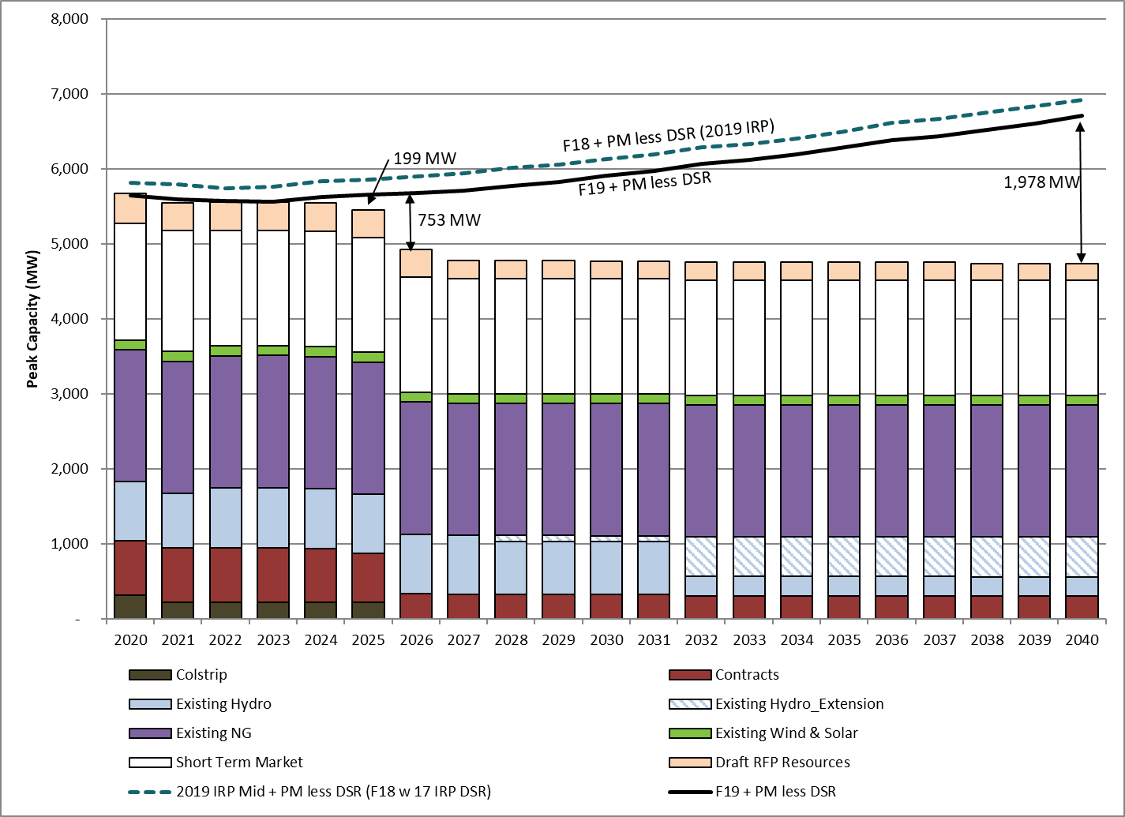

Due to its pending status, the impact of the announced sale of Colstrip unit 4 prior to 2025 is included as a separate line item in Table 1 (below). The sale is expected to result in a need for new capacity resources beginning in 2021. Due to the relatively small size of the deficit between 2021 and 2023 (less than 50 MW), PSE intends to issue a separate RFP for short‐term resources to meet this need.

Table 1. ***Cumulative capacity need by year***



## DR Resource Objectives and Bidder Solution Requirements

PSE’s objectives for DR as a portfolio resource in the 2021-2025 contracting period are listed below. The primary objectives are requisite (or the minimum) requirements that a bidder needs to fulfill for PSE’s future DR portfolio.

**Primary Objectives:**

1. Ensure DR resource is cost effective[4] and can meet the following performance requirements:
   1. Be available during weekday peak hours, typically between 7 a.m. to 10 a.m. in the morning, and 5 p.m. to 9 p.m. in the evening, from November 1 through February 28/29.[5] PSE may call DR events outside these time windows, but bidders will not necessarily be expected to provide the same level of curtailment.
   2. Provide load response with one of the following notification options: (1) hour ahead notification of calling DR events, (2) day ahead notification of calling DR events, or (3) a combination of hour ahead and day ahead notification of calling DR events.
   3. The total event time from November 1 through February 28/29 shall be no more than 40 hours per individual product.

**Secondary Objective:**

1. Develop flexible DR capability that provides more rapid curtailment, and greater integration of DR dispatch with grid monitoring.
2. Provide fast response with notification time of 10 minutes or less.
3. Provide Fast Frequency Response (10-15MW) with notification time of less than one minute (52 seconds).

**Targeted Demand Response:**

The TDR team works to support the Delivery System Planning (DSP) efforts of the Electric and Natural Gas infrastructure planning teams. Specifically as related to Non Wires Alternatives (NWA) and Non Pipe Alternatives (NPA) analysis for T&D Deferral projects. As projects are identified and capacity constraints are verified, load curtailment needs will be planned. These projects will also be served by the objectives above.

# Scope of Work

This section identifies some, but not necessarily all, of the roles and responsibilities of PSE and the selected vendor. Bidders will be expected to identify specific information needed from PSE as well as additional responsibilities required by bidders to successfully deploy the load curtailment technologies and meet the stated objectives described in Section 2.2. Successful bids must also articulate the implementation strategy.

## Roles and Responsibilities

Table 4 below summarizes PSE and vendor responsibilities with respect to core business functions associated with DR program design and delivery.

Table 4. DR Business Functions and Responsible Parties

|  |  |  |
| --- | --- | --- |
| Business Function | Responsible Party | |
| **PSE** | **Vendor** |
| Define Program Parameters and Initiate Load Control Events | P, A | - |
| Provision of Technology Products and Services | - | P, A |
| Marketing, Customer Recruitment & Outreach | A, p | P |
| Technology Installation and Enablement | p | P, A |
| Data Support and Performance Analysis | p | P, A |
| Billing and Settlement | A | P |
| Customer Service and Satisfaction | P, A | P |
| EM&V[6] | P, A | - |
| Coordination with Energy Efficiency Programs | P, A | P |

*Level of Responsibility:*

**A** = Accountable (answerable for the correct and thorough completion of the deliverable or task, and often the one who delegates the work to the performer)

**P** = Perform (carries out the activity)

p = Performs with a lower level of responsibility than P

Blanks indicate that the party is neither accountable nor responsible.

PSE values its relationships with customers. It prefers to work with services partners that understand these relationships and combine a high degree of technical expertise with superior customer-focused awareness and service during program planning and implementation. It is PSE’s preference to ‘own’ the customer relationship with the selected respondent and co-coordinate PSE Demand Response implementation efforts among Business Services, Energy Efficiency Services and other customer service and program implementation conduits.

The vendormust ensure that its products and services are appropriate for the program objectives described in Section 2.2. The vendor’s roles include, but are not limited to, providing the following over the life of the contract:

The tables below provide brief descriptions of PSE and vendor roles and responsibilities with regard to the business functions earlier in Table 4.

*Define Program Parameters and Initiate Load Control Events*

|  |  |
| --- | --- |
| ***PSE Responsibility*** | ***Vendor Responsibility*** |
| * Define DR program parameters (applicable months, event hours, cycling and/or temperature set point modifications; notification, event duration, annual limit on event hours, no. of times events can be called, etc.). * Initiate load control events using vendor-provided software and hardware. | *Not Applicable* |

*Provision of Technology Products and Services*

| ***PSE Responsibility*** | ***Vendor Responsibility*** |
| --- | --- |
| *Not Applicable* | For all customer classes:   * The technology and its support. The vendor should present a fully-integrated architectural solution that includes the following elements: * Utility Interface (UI) * Head-end application * Load control devices * All necessary communications between UI, head-end, and load control devices (may leverage the customer’s broadband internet). * A customer web portal and mobile app, if the load control devices require customer interaction. * Ability to do each of the following: * Curtail the contracted amount of load within an hour of dispatch by PSE. * Selectively control the amount and duration of load shed in a predetermined manner. * Control remote devices, individually, as a whole, or as multiple groups, based on device type. * Provide curtailment forecasts for full deployment, including seasonally, monthly, and day-ahead. * Produce near real-time monitoring of curtailments in process. * Provide post event reporting on load shed achieved.   For commercial and industrial participants:   * Undertake preventive, routine, and non-routine maintenance on program equipment and software to ensure reliable long-term and safe operation. |

*Marketing, Customer Recruitment and Outreach*

| ***PSE Responsibility*** | ***Vendor Responsibility*** |
| --- | --- |
| * Assume primary responsibility for marketing, customer education and outreach * Work in close coordination with vendor in developing program marketing materials, website and digital tools, customer education and outreach. * Ensure focus on PSE brand in messaging. * Recruit customers in coordination with the vendor: PSE’s energy efficiency program staff will serve as a primary touchpoint to customers during all stages of customer recruitment. | * Jointly develop program marketing materials and digital tools and assets with PSE. * Recruit customers in close coordination with PSE energy efficiency program staff and other relevant groups. * Enroll, schedule, install, enable, verify, and test the program participants. |

*Technology/Equipment Installation and Enablement*

| ***PSE Responsibility*** | ***Vendor Responsibility*** |
| --- | --- |
| * PSE Account Managers, Energy Management Engineers and/or energy efficiency program staff works closely with the vendor during preliminary site assessments. * Where appropriate, PSE staff introduce vendor to customer for detailed site audit. * PSE staff works in close coordination with vendor at different stages of technology enablement: schedule, install, enable, verify, and test the program participants. | * Provide vehicles with proper signage in support of installation activities. PSE to approve signage for vehicle. * Set up network/workforce to install and service program equipment. * Provide field and office training, including safety training for field personnel. * Manage all inventories of equipment, materials, and supplies associated with installation of program equipment and software. * Perform quality assurance audits on all installations by a new employee. * Perform maintenance/inspection and repair for all installed equipment. |

*Data Support and Performance Analysis*

| ***PSE Responsibility*** | ***Vendor Responsibility*** |
| --- | --- |
| * Provide export of customer data for use by the vendor. Bidders should define initial interface requirements. * Mutually define with the bidder data field names, definitions, data type, and data sizes of all transferred/shared data; provide an interface to the vendor’s system(s) for import of data required by the bidder. * Undertake program performance analysis using key metrics. | * Provide secure, data uploads into PSE’s data tracking system. * Provide participant data from a sufficient sample of customers for purposes of estimating average load impacts. |

*Evaluation, Measurement and Verification (EM&V)*

| ***PSE Responsibility*** | ***Vendor Responsibility*** |
| --- | --- |
| * Sponsor independent ex-post impact and process evaluation of the program(s), establish baseline development methodologies and analytical framework for conducting annual impact and process evaluations. | * Provide participant data (to PSE and 3rd party evaluator) from a sufficient sample of customers for purposes of estimating average load impacts. * The respondent will be called upon to provide meter and payment data, calculation methodologies and other relevant information related to enrolled participants. |

*Billing, Payment, Measurement & Verification*

| ***PSE Responsibility*** | ***Vendor Responsibility*** |
| --- | --- |
| * Undertake customer incentive payments. | * Conduct measurement and verification for estimation of load impacts (method to be agreed upon mutually with PSE, and verified by PSE and an independent contractor). |

*Customer service and satisfaction*

| ***PSE Responsibility*** | ***Vendor Responsibility*** |
| --- | --- |
| * Perform customer satisfaction measures at all major points of customer interaction in order to improve/maintain customer satisfaction with program. * Develop customer satisfaction metrics along with vendor and obtain information from vendor to assess customer satisfaction. * Conduct surveys and focus groups in coordination with vendor to assess customer satisfaction.[7] | * Coordinate with PSE to perform customer satisfaction measures at all major points of customer interaction in order to improve/maintain customer satisfaction with program. * Exchange customer information with PSE as mutually agreed. * Perform all activities related to customer complaint tracking and handling. * Perform all activities related to customer claims tracking and handling. * Perform all activities associated with maintaining a call center operation including, but not limited to, customer recruitment, handling all types of enrollments, installation scheduling, and service call processing, complaint handling, and tracking. * Allow PSE to monitor customer service calls with customers. |

*Coordination with Energy Efficiency Programs*

| ***PSE Responsibility*** | ***Vendor Responsibility*** |
| --- | --- |
| * + Assume responsibility for coordination of DR and EE products/services to provide integrated demand side management opportunities to customers. | * Work in coordination with PSE’s program managers and implementers on ways to integrate DR and EE program offerings to present these as integrated energy management opportunities to customers, especially at the stage of program marketing, customer education and outreach. |

## Performance Goals

PSE will pay bidders based on megawatts of delivered load reduction that meet the performance parameters identified under the Objectives in Section 2.2. These payments will be provided as:

* **Monthly capacity payments**, based on the average actual load reduction provided during events that month or, if no events occurred, the monthly committed load reduction specified by the vendor, multiplied by PSE’s monthly capacity payment rate.
* **(Optional) Monthly energy usage payments**, based on the vendor’s energy performance each month, multiplied by PSE’s hourly energy usage payment rate.
* **Other payments** as structured in bidder’s response in the Pricing Attachment and agreed upon with PSE.

If the vendor fails to commit or deliver megawatts greater than or equal to the minimum committed load reduction specified in the contract during a program month, PSE will reserve the right to withhold some or all of the monthly payments to the vendor for that particular program month.

Additionally, in order to ensure successful delivery of products and services, bidders’ performance and compensation will also be measured against pre-defined metrics specified during the contract process, which may include the following:

*Technology Products and Services*:

* System functionality meeting specifications identified in bidder proposal
* Data collection/provision requirements (types of data and frequency of provision)
* Device diagnostics capabilities and frequency of provision
* Event monitoring and performance reporting (speed, comprehensiveness, and frequency)

*Implementation Services*:

* Timely enrollment of participants
* Timely installation of equipment
* Minimum levels of customer service satisfaction
* Timely provision of customer enrollment data and forecasts
* Accurate customer enrollment data and payment processing

*Curtailment Objectives:*

* Annual growth targets
* Cumulative curtailment capability
* Event performance
* Timely provision of required event data, analysis and forecasts

# Technical Proposal

**PSE will consider any type of end use control technology**, **delivery mechanism**, **or combination of technologies and delivery mechanisms**, provided the proposed solution meets PSE’s objectives stated in Section 2.2.

In the tables below, please describe the products, services, and information you would provide if selected by PSE to perform the Scope of Work described above in Section 3. Where appropriate, bidders are asked to describe their past experiences and how they may enhance the bidder’s ability to meet PSE’s objectives outlined in Section 2.2.

**Not all fields below will apply to all vendor solutions.** Bidders should indicate fields that are not applicable to their proposed solution in their response.

Bidders may provide their responses in the format of the tables below, if desired. At a minimum, bidders must conform to the alpha-numeric outline of the sections, topics, and questions (e.g., System level diagram must be indicated as part of Section 4.1.B.1 Technology Products and Related Services, System Overview, System Level Diagram).

Bidders are also encouraged to provide clear, concise responses. In addition, bidders should feel free to reference to earlier sections for their responses if they feel the requested information would be repeated.

*Example Response Format:*

**Section 4.1 Technology Products and Related Services**

**B. System Overview**

1. System Level Diagram

[insert diagram here]

1. Description of Features/Functions

[insert text response here]

## Technology Products and Related Services

|  |  |
| --- | --- |
| 1. **Summary of Proposal** (2-page limit) | |
| 1. Summary of Proposal for Technology Products and Related Services | Provide a high-level overview of your proposed technology, associated hardware and software, and any technology-related services. This should be a concise summary of the offering that you propose in the remainder of this Section, highlighting unique elements of your proposal including Key Proposal Inputs outlined in Exhibit E. This summary should NOT address Implementation Services, which are covered in Section 4.2. |

|  |  |
| --- | --- |
| 1. **System Overview** | |
| 1. System Level Diagram | Provide a system level block diagram of the solution that you are proposing. Include head-end (control) elements, all key interfaces, databases, communication, monitoring, switches, and associated technology to deliver a load shed signal to the customers and end devices, and the return path for communications back to PSE. PSE prefers a two-way communication infrastructure.  Note: PSE will not accept marketing brochures or any extraneous marketing information to fulfill this request, but may be included in an appendix. A simple but detailed block diagram that is easy to read and understand is mandatory. |
| 1. Description of Features/Functions | Based on the system-level diagram, describe the major functions/features of that system. |
| 1. End-Use Control Devices and Systems | Provide technical descriptions of any end-use devices and systems you are proposing for customer premises as well as the end-uses they might control. |
| 1. Communications Infrastructure | Based on the system-level description, provide a complete description of the communication infrastructure that will be needed and how it will be used.  Discuss the flexibility and adaptability of communications options used to monitor, control, and manage the remote devices. Discuss your ability to upgrade the communications options to adopt new technology and/or systems and services (e.g., AMI). Provide information about your proposed future communication options, the proposed time frame for these, and the additional features and capabilities this will provide. |
| 1. Metering | Describe the type of metering that will be employed and how metering information will be relayed to PSE—frequency, resolution, summary reporting, etc. Also indicate any requirements for PSE’s installed metering, or bidder’s intended use of PSE meter data.  Note: PSE is updating our electric metering equipment across our entire service territory. This is a six-year project, scheduled to complete in 2023.  PSE is currently installing the following technology:   * Residential Meters: E331/E351 FOCUS AXe (2S, 12S and 2SE) * Commercial Meters: E650 S4x-4S   For the most current information on PSE’s Meter Upgrade Project, including project maps and schedules, please visit our website: <https://www.pse.com/pages/meter-upgrade/map-and-schedule> |
| 1. Load Curtailment Mechanics | Describe the approaches, processes, and equipment to be used to execute load curtailment at customer facilities.  Discuss the anticipated actions required of customers (may vary by customer), and any automated load response that may be employed. |
| 1. Interoperability | Based on the system-level diagram, describe the interoperability features of each element of your solution and the scalability of your proposed solution. Discuss any components that may not be interoperable with future deployments and why this is the case.  Describe the communication and control center protocols that you support (e.g., CIM, Multispeak, etc.) and the open interoperability standards that your interfaces are based on. Provide your interoperability roadmap that shows your future direction for these protocols, along with timing and rationale. |
| 1. Security | Describe in detail the system architecture and measures that provide end-to-end security and cyber-security and ensure against attacks to program-related systems and data. Include discussion of secure data transfer, communications, device registration, and device messaging, and in particular customer related information privacy and security. |
| 1. Maintenance | Describe the maintenance requirements and activities during the project phase. Include any equipment required and describe how the maintenance will be performed.  Also, describe any expected software maintenance. |
| 1. Upgrades | Describe how the devices will be upgraded over their lifetime and whether and how they will be able to comply with changing industry standards. |
| 1. Requirements for PSE | Describe the expectation of PSE technology infrastructure, including server needs, database requirements and capacities, operating systems, security requirements, file transfer mechanisms, telecom requirements, and any other interfaces, components or software/hardware requirements. |

|  |  |
| --- | --- |
| 1. **Head-End (or Control) System** | |
| 1. Technical Descriptions | Based on the system-level diagram, provide technical descriptions of the system management software that is proposed for the control of all deployed load control equipment and other infrastructure that may need to be controlled and managed. |
| 1. Operator Interface | Describe and provide graphics (screen captures or other appropriate) illustrating what an operator would see, and what they would do to set up an event, trigger the event, and then monitor its progress and effectiveness. |
| 1. Control Strategy Validation | Describe how your process will be tested when new load control strategies are implemented. |
| 1. Hosting | Based on the system-level diagram explain the options of whether the interface is hosted at the utility or the bidder’s site as SaaS or a Cloud Based solution. |
| 1. Status and Reporting | Based on the system-level diagram, describe your reporting capability as it relates to displaying the current system status and to log system status and activity for subsequent analysis.  Describe the data reports available for each element of the system. |

|  |  |
| --- | --- |
| 1. **Load Curtailment Performance and Impact Assessment** | |
| 1. Load Curtailment Performance to Meet Objectives | ***\*\*\* PSE places a high value on responses to this item. \*\*\****  Describe the proposed load curtailment capability, including number of events and hours per year, duration of events, frequency of events, advanced notification required, and other relevant performance metrics associated with load curtailment that meets PSE’s objectives in Section 2.2. |
| 1. Winter Capacity Reduction Estimates by Year | In the table below, provide your proposed winter peak load reduction capacity per year from 2021 to 2025[8]. The proposed amount indicates what bidder can provide that meets PSE’s objectives discussed previously in Section 2.2.  Winter Load Curtailment Estimate Per Year[9] (MW)   |  |  |  |  |  |  | | --- | --- | --- | --- | --- | --- | |  | **2021** | **2022** | **2023** | **2024** | **2025\*** | | **Day Ahead** |  |  |  |  |  | | **1 Hour Ahead** |  |  |  |  |  | | **10 Minute** |  |  |  |  |  | | **Total** |  |  |  |  |  | |
| 1. Customer Baselines and Alternative Baseline Loads | PSE will provide a baseline methodology to calculate the winter peak load reduction, as discussed under the primary objectives in Section 2.2. PSE anticipates utilizing a day-matching approach (using customer loads from one or more prior days during the same hours as the event) with a symmetric up or down day-of event adjustmentP23F[10]P (so that the adjusted baseline matches the observed load during certain hours prior to the event). However, the specific methodology has not been established. For purposes of this RFP, bidders should assume that megawatts will be measured based on each customer’s average load reduction measured over each 15-minute interval during the course of each event.   1. Please describe your approach to comply with these measurement requirements.   If you are providing load curtailment products for which a day-matching baseline with same-day adjustment is not appropriate, please describe your proposed baseline approach. |
| 1. Reliability | Describe your approach to ensuring consistent load reductions during the course of an entire event and from one event to another. Provide data/graphical evidence of your performance history in doing so. |

## Implementation Services

PSE values its relationships with customers. It is PSE’s preference to ‘own’ the customer relationship with the selected respondent and co-coordinate PSE Demand Response implementation efforts with energy efficiency program/services offerings and other customer service and program implementation conduits.

|  |  |
| --- | --- |
| 1. **Summary of Proposal** (2-page limit) | |
| 1. Summary of Proposal for Implementation Services | Provide a high-level overview of your proposed implementation services. This should be a concise summary of the offering that you propose in the remainder of this Section 4.2, highlighting unique elements of your proposal. |

|  |  |
| --- | --- |
| 1. **Marketing, Recruitment, and Retention** | |
| 1. Customer Segmentation | Provide a complete list of all customer sectors and end-uses targeted for participation in the program.  In the table below, provide an estimated share of the total curtailment amount in 2025 by customer sector, presented in terms of their percentage contribution to the total winter peak load reduction in 2025.  % share by sector in winter peak load curtailment   |  |  | | --- | --- | | **% share by sector** | **2025** | | Residential |  | | Small commercial  (<=50 kW max. demand) |  | | Medium commercial  (>50 kW and <=150 kW max. demand) |  | | Large Commercial (>150 kW max. demand) |  | | Total | 100% | |
| 1. Engagement Plan | Detail the strategy for public outreach, deployment and plan to engage end-use customers and solicit enrollment into a program.   * Include discussion of the particular customer sectors and sub-sectors to be targeted. * Provide examples of how you might coordinate with PSE account managers and existing PSE programs to improve program marketing and recruitment. |
| 1. Branding | Describe the “brand recognition” of any customer interaction, equipment, or systems which the end-use customer may encounter, such as the customer portal. |
| 1. Incentive Payments | * Propose a customer incentive structure, if your marketing plan calls for incentives. Include discussion of any incentives for initial enrollment, on an annual basis, for equipment, or other variation. * Provide a rationale for your proposed incentive structure, and provide alternative structures and rationales, if desired. PSE is not predisposed to the use of monetary incentives and understands that the provision of a thermostat and related services, for example, may be sufficient incentive.   Note that PSE will be responsible for administering incentive payments to participants. |
| 1. Coordination with PSE | Describe how you will coordinate with other existing PSE programs to improve the program delivery. Include discussion on how you and PSE could cross-promote and integrate your offering with existing/future EE programs, etc. [11]   * Provide examples of how your firm has successfully partnered with other existing utility programs to enhance program delivery. |

|  |  |
| --- | --- |
| 1. **Equipment Installation and Operation** | |
| 1. Staffing | Describe your current network of equipment installers and/or your proposed subcontractor or subcontracting approach for installation of load control devices and related equipment. Discussion should address the following:   * Existing or planned coverage in/near PSE service territory * Your qualification requirements for using subcontractors and your process for identifying, training, and utilizing local contractors, if applicable * Your process for evaluating performance, ensuring professional conduct, and maintaining adequate capacity to meet program goals |
| 1. Processes | Describe the installation process for any customer equipment. Include discussion of the equipment needed to complete installation, amount of time needed to install a facility, and any requirements from the customer. |
| 1. Verification of equipment operation | Describe your practices for verification and testing of equipment while installer is onsite. |
| 1. Equipment maintenance | Describe your maintenance, auditing, and repair practices for installed devices to ensure continued operation (this may include site visits and/or use of two-way communications to verify operation). |

|  |  |
| --- | --- |
| 1. **Data Support** | |
| 1. CIS and work management software | Describe your CIS and work management software, including how customer information is entered and updated, how scheduling of installations is accommodated, and how service requests and other necessary information are incorporated. |
| 1. Interface Requirements | Describe the process by which PSE’s system is updated or fed with real time information, such as load curtailment activity and other predefined fields. Also, describe processes for providing updates/reports. |
| 1. Data Sharing and Reporting | Respond in detail to the following:   * What types of information/data will be exchanged with PSE, and how will this data be transferred in a secure manner? Is it pulled, pushed on a time basis, or both? * What access will PSE staff have to account status, and what information will be available? * What types of status reporting will be provided to PSE, with what level of detail, and with what frequency? * What are your data retention policies? * What is your QA/QC process for ensuring that your customer data is correct and valid? |
| 1. Reliability and Backup | Describe the protections and recovery methods for dealing with unforeseeable events (e.g., acts of nature, computer or hard drive failure in the computing resources, or security breaches) that may compromise vital customer or work management data. |
| 1. Testing Approach | Describe how the data transfer processes will be tested initially and how they will be checked during the project to assure functionality and accuracy. |

|  |  |
| --- | --- |
| 1. **Customer Service and Satisfaction** | |
| 1. Service calls | Describe your method of responding to customer service requests requiring onsite visits. What is the typical time from the service call to a response from a scheduler? To resolution of the problem? How are decisions made regarding whether service work is needed and covered under your responsibilities? |
| 1. Customer satisfaction | What procedures do you propose to ensure customer satisfaction and to measure and report results to PSE? What metrics could be easily provided short of any detailed customer satisfaction surveys that PSE might conduct? |

|  |  |
| --- | --- |
| 1. **End-of-Contract Terms** | |
| 1. End-of-Contract Technology Ownership Terms | * Indicate who owns the equipment, and what your suggested terms are for ownership of equipment at the end of the contract period in 2025, should PSE decide to discontinue services with your firm at that time. * Indicate whether it is possible for PSE buy the equipment and/or acquire a license to operate the head end system at the end of the contract period. * Provide pricing terms for the ownership transfer or licensing. |

## Project Management

PSE values its relationships with customers. The utility prefers to work with services partners that understand these relationships and combine a high degree of technical expertise with superior customer-focused awareness and service during program planning and implementation. It is PSE’s preference to ‘own’ the customer relationship with the selected respondent and co-coordinate PSE Demand Response implementation efforts among Business Services, Energy Efficiency Services and other customer service and program implementation conduits.

|  |  |
| --- | --- |
| 1. **Roles and Expectations of PSE** | |
| For each of the major (lettered) topic areas above and for any other relevant topics, discuss the role that you expect PSE to play and any specific needs/expectations in terms of providing information, services, and feedback. | |
| **Topic Area** | **Role and Expectations of PSE** |
| 1. Marketing, Recruitment, and Retention |  |
| 1. Equipment Installation and Operation |  |
| 1. Data Support |  |
| 1. Customer Service and Satisfaction |  |
| 1. Other |  |

|  |  |
| --- | --- |
| 1. **Schedule and Delivery** | |
| 1. Implementation Timeline | Provide a detailed schedule for major implementation tasks, including, but not limited to program startup activities, marketing, equipment installation, establishment of communications infrastructure, system testing and program operations.  If the schedule depends on unknown factors at this time, describe those factors and how they could impact the schedule and program (e.g., lead-time constraints). |
| 1. Extenuating factors | What extenuating factors may affect performance and schedule? How might these impact program rollout and what can be done in advance by the implementation contractor or by PSE to avoid affecting program rollout and/or to mitigate their impact? |

# Bidder Information and Qualifications

In the tables below, please provide company information, relevant project experience, and references. See the introduction to Section 4 Technical Proposal above for guidance on the format of your response.

|  |  |
| --- | --- |
| 1. **General Company Info** | |
| 1. Bidder Name | Legal company name |
| 1. Address(es) | Include headquarters address as well as other relevant addresses for PSE (e.g., local offices in Washington, etc.) |
| 1. Description | Company description/ history |
| 1. Other information | 1. Form of organization: corporation; partnership; individual d/b/a; or other as applicable. 2. State of incorporation or registration 3. Federal Identification Number or Social Security Number as applicable 4. Website URL 5. Is your company capable of receiving payments via a Financial Electronic Data Interchange (FEDI)? If not, would you consider establishing an account with a financial institution that is FEDI capable? |
| 1. Financial Statements | Audited financial statements for past three years (submit as attachment) |
| 1. Contact | Name, address, telephone number, and email address of primary bidder contact. |

For each subcontractor being proposed, provide the information in Table A, Items 1 through 4d.

|  |  |
| --- | --- |
| 1. **Relevant Project Experience** | |
| 1. Existing Customers | List existing demand response program utility customers. |
| 1. Customer Documentation | Provide documentation that describe up to five existing utility customers of your proposed system solution (type of installations, # devices, implementation services provided). Clarify any differences with what you are proposing in this RFP. You may reference marketing materials provided as an attachment to your proposal. |
| 1. **References** | |
| 1. Contact Information and Summary | Provide a company name, contact name, phone number, and email address for **three customers** that can be contacted about your relevant work for them. Include a brief description of the project if not already described in Item B1 above. |

# Proposal Format and Bidder Instructions

Proposals should provide a concise yet complete description of the bidder’s approach, capabilities, and pricing for satisfying the required services outlined in this RFP. Bidders are required to prepare their proposal response according to the content described in the Bidder Checklist below. Specific bid instructions and requirements for the proposal format and content are as follows:

1. Proposals should contain, in proper order, all items listed and described in the Bidder Checklist below. Many of these items refer to more detailed questions or instructions contained in Sections 4 and 5 of this RFP. The organizational structure (numbering system) of the questions/instructions in these sections must be used to describe the proposed services. Bidders do not need to provide responses in the tabular format used in Sections 4 and 5, but the category letter, topic number, and topic name should be clearly labeled to identify which question/information request is being addressed.
2. PSE has not established specific page limits. However, **bidders are encouraged to be concise in their responses**, answering the questions directly and referencing supplemental materials in an appendix where necessary.
3. Additional materials that the bidder believes *will substantially improve PSE’s understanding of the bidder’s capabilities and/or proposal* may be submitted as appendices or attachments.

**Requirements for bid submission are discussed in Section 7.**

**Bidder Checklist**

| **Item** | **Description** |
| --- | --- |
| Intent to Bid | Complete and submit Intent to Bid Form provided as a separate attachment. To be submitted by August 21, 2020. |
| Mutual Non-Disclosure Agreement | To be submitted by August 21, 2020. |
| *Technical Proposal Documents, including:* | |
| Table of Contents | Identifies all major sections of the proposal and their starting page numbers |
| Technical Responses | Responds to all questions in RFP Section 4 regarding your proposed technology solution. |
| Bidder Information and Qualifications | Responds to all questions in RFP Section 5 regarding your organization, experience, and references. |
| *Pricing Proposal Document, consisting of:* | |
| Pricing Proposal | Provide pricing by responding to all questions and instructions contained in the Pricing Attachment to this RFP. |

* 1. **Bidder Selection Process**
     1. ***Minimum Qualifications***

Bidders responding to this RFP must have at least the following qualifications to be considered for selection:

* At least five years of experience with providing load curtailment technology or delivering similar types of load management programs for utility sponsored or ratepayer funded programs.
* Demonstrated organizational, financial, and data tracking and reporting abilities.
* Demonstrated commitment to quality and customer service.
* Contractors are encouraged to locate key delivery team members in Washington. Staffing of the prime contract manager in Bellevue, WA is strongly preferred.
  + 1. ***Proposal Evaluation Criteria***

Proposals will be reviewed and bidders selected for interviews and/or contract negotiations based on a variety of criteria including, but not limited to: demonstrated competence and experience; management structure and assigned personnel; quality of proposed equipment and services; pricing; and performance guarantees.

PSE reserves the right to contact a bidder at any time for clarifications about any part of the Bidder’s proposal. Proposal review questions and communications will focus on clarifying the information set forth by the Contractor in the proposals and will not be an opportunity for the Contractor to revise terms.

# RFP and Bid Procedures

This section of the RFP addresses procedures governing the submission of bids and the solicitation process.

* 1. **RFP Schedule**

The anticipated schedule for this solicitation, subject to change at PSE’s sole discretion, is as follows:

|  |  |
| --- | --- |
| **Date** | **Milestone** |
| May 4, 2020 | Draft RFP filed with WUTC |
| July 6, 2020 | Public comment period closes |
| August 3, 2020 | WUTC expected to approve PSE's Demand Response RFP |
| August 14, 2020 | PSE releases final RFP solicitation |
| August 21, 2021 | Mutual Confidentiality Agreements and Intent to Bid due to PSE |
| September 4, 2020 | Offers due to PSE |
| Q1 2020 | PSE selects final short list, notifies respondents |

The above schedule is subject to change at the discretion of PSE. Notification of changes may be sent by PSE to the individual designated as bidder’s contact (in either the intent to bid or the proposal).

* 1. **Intent to Bid**

Bidders are strongly encouraged, although not obligated, to indicate their “intent to bid” by submitting the intent to bid form no later than August 21, 2020 to the DR RFP email address at [DemandResponse@pse.com](mailto:DemandResponse@pse.com).

Bidders providing an Intent to Bid will receive follow-up communications from PSE regarding clarifications or changes to the RFP and the solicitation process.

PSE will issue this RFP to all qualified bidders. If your organization is interested in bidding but did not receive the invitation to bid, you may send an email to [DemandResponse@pse.com](mailto:DemandResponse@pse.com).

PSE will not accept responses from any PSE affiliates or subsidiaries. PSE also will not accept responses from other electric utilities.

* 1. **Questions and Communications**

**Technical or program-related questions** related to this RFP should be submitted by email to the RFP email address at [DemandResponse@pse.com](mailto:DemandResponse@pse.com) after issuance of this RFP. Questions should be provided in writing by August 21, 2020.

**Commercial or administrative questions** related to this RFP may be submitted at any time by email to [DemandResponse@pse.com](mailto:DemandResponse@pse.com).

No other contact with PSE employees or its contractors related to this RFP shall be made throughout this entire process. Any unauthorized contact may result in immediate disqualification.

**RFP website:** RFP documents, responses to bidder questions, and other relevant material will be posted to PSE’s RFP web site at <https://pse.com/DR_RFP>.

* 1. **Submission of Proposal Responses**

Bidders must submit both hard copy and electronic versions of their proposals by the due date and time listed below. Any proposals received after this date and time may be rejected. Proposals that do not contain the information requested in this RFP may also be rejected at PSE’s sole and absolute discretion.

1. **Deadline for Submission** – September 4, 2020 at 5:00 p.m. (Pacific Time) for electronic copies to be received by PSE. Hard copies must be postmarked or shipped by the deadline, but may be received by PSE the following business day.
2. **Proposal Submission** – Bidders are required to submit both hard copies and electronic copies of their proposal as follows:

**Hard copies.** Bidder shall submit **two (2) hard copies** of their proposal. Hard copies should include the Technical Proposal Documents, and any other attachments or supplemental materials that bidder wishes to provide (see Bidder Checklist in Section 6 above). Responses to the Pricing Attachment should be contained in a separately bound document, but may be included in the same package. Proposals must be enclosed in a sealed envelope or box clearly marked “Demand Response Proposal” and sent to the following address:

Attn: Demand Response  
Puget Sound Energy  
355 110th Ave NE

Bellevue, WA 98004

**Electronic copies.** In addition to the hard copies, bidders shall email **two electronic copies** of their full proposal to [DemandResponse@pse.com](mailto:DemandResponse@pse.com). One copy should be in PDF format, for internal distribution, and a second in Microsoft Word for purposes of facilitating preparation of contracts. Electronic copies should be organized into the following separate files (see Bidder Checklist in Section 6 above):

* Technical Proposal
* Pricing Proposal
* Other attachments or supplemental materials.

Important: Please note that emails with attachments larger than 10MB may not pass through PSE’s firewall. Bids should be submitted via separate emails if necessary to ensure that attachments do not exceed this limit.

1. **Verification of Receipt of Proposal** – It is the bidder’s sole responsibility to ensure that hard copies of its proposal are sent by the deadline and received at the address specified above no later than the following business day.
2. **Errors or Omissions –** A bidder that discovers an error or omission in its proposal response package may withdraw that package and resubmit one, provided that it does so before the deadline for submission of proposal responses.
3. **RFP Withdrawal** – PSE reserves the sole and absolute right to withdraw this RFP at any time before the duly authorized execution of the contract/purchase order with bidders for any reason including, but not limited to, action by the Washington Utilities and Transportation Commission (UTC) or changes in forecasted resource needs. In its sole and absolute discretion, PSE may accept or reject any or all proposals, and may accept other than the lowest-cost proposal. PSE will not assume any liability, under any circumstances, to any bidder submitting a proposal in response to this RFP.
4. **Proposal Preparation Costs** – Bidder accepts any and all costs and expenses incurred prior to the duly authorized execution of the contract/purchase order and will not seek any costs and expenses from PSE. This includes proposal preparation and any requested on-site interviews or contract negotiation expenses.
5. **Proposal Confidentiality** – To the extent possible, PSE will attempt to keep submitted proposals confidential. However, it is possible that proposals may be requested by the WUTC for review, or by other interveners, and as such, full assurance of complete confidentiality is not possible. To the extent required by law or regulatory order, PSE will make available to the public a summary of all proposals received and the final ranking of all such proposals. Furthermore, PSE will not assume any liability to a Bidder or other party as a result of any public disclosure of any proposal or contract/purchase order.
   1. **Terms and Conditions of Submission**

All proposals, along with all other documentation, submitted in connection with this RFP shall become and will remain the property of PSE and will not be returned to the Bidder.

By submitting a proposal pursuant to this RFP, Bidders acknowledge and agree that (a) they will be fully bound by the terms and conditions of this RFP and PSE Terms and Conditions in submitting their proposals, (b) they have had the opportunity to seek independent legal and financial advice of their own choosing with respect to the RFP and their proposals, (c) they have obtained all necessary authorizations, approvals and waivers, if any, required by them as a condition of submitting their proposals, (d) they are submitting their proposals subject to all applicable laws, and (e) they have not engaged and will not engage in communications with any other Bidder in the RFP concerning the price or other economic terms contained in their proposals and have not engaged in collusion or other unlawful or unfair business practices in connection with this RFP.

* + 1. ***Reservation of Rights and Disclaimers***

This program and any contracts signed in association with it are and will be contingent upon Washington Utilities and Transportation Commission (UTC) approval. PSE reserves the right not to accept the proposals of any of the respondents to this RFP. PSE also reserves the right not to make an award, to re-bid the proposed program, to decline to enter into an agreement with any respondent and to terminate negotiations with any respondent, all at PSE’s sole discretion.

PSE reserves the right to revise, suspend, or terminate this RFP process and any associated schedules at its sole discretion without liability to any person or entity responding to this RFP or any other person or entity. PSE will communicate by e-mail to respondents regarding any changes to this RFP, schedules, or the RFP process.

Respondents who submit proposals do so without legal recourse against PSE, PSE’s parent company or affiliates, and the directors, management, employees, agents or contractors of any of them, for any reason arising out of this RFP. Respondents are solely responsible for all of their costs incurred to prepare, submit, or negotiate its proposal, a definitive agreement, or any other activity related thereto.

* + 1. ***Post Proposal Negotiation and Awarding of Contracts***

PSE reserves the right to negotiate both price and non-price factors during any post-proposal negotiations with a finalist. PSE has no obligation to enter into an agreement with any respondent to this RFP and may terminate or modify this RFP at any time without liability or obligation to any respondent. This RFP shall not be construed as preventing PSE from entering into any agreement that it deems appropriate at any time before, during or after this RFP process is complete. This includes requesting a clarification of the technical proposal and pricing of a firm proposed as a subcontractor should PSE wish to enter into direct contract negotiations with only the proposed subcontractor.

* 1. **Bidder Selection Process**
     1. ***Minimum Qualifications***

Bidders responding to this RFP must have at least the following qualifications to be considered for selection:

* At least five years of experience with providing load curtailment technology or delivering similar types of load management programs for utility sponsored or ratepayer funded programs.
* Demonstrated organizational, financial, and data tracking and reporting abilities.
* Demonstrated commitment to quality and customer service.
* Contractors are encouraged to locate key delivery team members in Washington. Staffing of the prime contract manager in Bellevue, WA is strongly preferred.
  + 1. ***Proposal Evaluation Criteria***

Proposals will be reviewed and bidders selected for interviews and/or contract negotiations based on a variety of criteria including, but not limited to: demonstrated competence and experience; management structure and assigned personnel; quality of proposed equipment and services; pricing; and performance guarantees. Exhibit D provides additional information regarding cost-effectiveness criteria.

PSE reserves the right to contact a bidder at any time for clarifications about any part of the Bidder’s proposal. Proposal review questions and communications will focus on clarifying the information set forth by the Contractor in the proposals and will not be an opportunity for the Contractor to revise terms.

* + 1. ***Negotiations and Finalizations***

Once the bidder(s) has been selected for the program, contract negotiations will be conducted. These negotiations will relate to the scope of work, specific program delivery features, program budgets, schedules, and payment terms. The contractual terms will include general terms and conditions. PSE reserves the right to simultaneously conduct negotiations with both the prospective vendor/contractor and an alternate bidder. PSE also reserves the right to terminate negotiations with any bidder in the event that PSE and the bidder are unable to agree on contract terms and conditions within a reasonable period of time to be determined in PSE’s sole and absolute discretion.

**Exhibit A: Schedule of Estimated Avoided Cost**

**Schedule of Estimated Avoided Cost**

This schedule of estimated avoided cost, as prescribed in WAC 480‐106‐040 and approved by UTC under Docket No. UE‐190665, identifies the estimated avoided cost and does not provide a guaranteed contract price for electricity. The schedule only identifies general information to potential bidders about the avoided costs. The schedule of estimated avoided costs includes the following two tables:

* **Table 1:** 2019‐2039 Avoided Energy Costs based on the Company’s forecast of market prices for the Mid‐C Market in PSE’s 2019 Integrated Resource Plan Progress Report as of November 15, 2019, pursuant to WAC 480‐106‐040 (a).
* **Table 2:** 2019‐2039 incorporates the avoided capacity costs as estimated in the Company’s 2017 Integrated Resource Plan (“IRP”) by resource type with the January 12, 2018 correction filed with WUTC under Dockets UE‐160918 and UG‐160919. The 2017 IRP was acknowledged by WUTC on July 8, 2019. Pursuant to WAC 480‐106‐040 (b) (ii), the 2017 IRP results for 2019‐2022 is replaced with the "projected fixed costs of a simplecycle combustion turbine".

1. ***2019 IRP Progress Report Forecast of Mid‐C Market Prices***

|  |  |  |  |  |  |  |  |  |  |  |  |  |  |
| --- | --- | --- | --- | --- | --- | --- | --- | --- | --- | --- | --- | --- | --- |
| (Nominal $/MWh) | | | | | | | | | | | | | |
|  | Jan | Feb | Mar | Apr | May | Jun | Jul | Aug | Sep | Oct | Nov | Dec | Avg. Annual |
| 2019 | 32.32 | 32.31 | 23.64 | 19.78 | 13.31 | 16.52 | 22.66 | 24.54 | 25.87 | 24.56 | 24.79 | 27.48 | 23.98 |
| 2020 | 25.94 | 26.26 | 21.04 | 17.86 | 13.07 | 14.56 | 20.47 | 23.3 | 24.06 | 23.82 | 23.61 | 24.97 | 21.58 |
| 2021 | 23.41 | 24.05 | 19.17 | 15.62 | 10.92 | 12.37 | 19.40 | 22.33 | 23.71 | 24.41 | 23.52 | 24.56 | 20.30 |
| 2022 | 22.37 | 23.22 | 17.52 | 14.61 | 9.40 | 9.94 | 17.85 | 21.53 | 23.04 | 23.15 | 22.14 | 24.19 | 19.08 |
| 2023 | 21.22 | 22.3035.81 | 15.50 | 13.99 | 10.21 | 9.65 | 17.91 | 21.41 | 23.38 | 23.10 | 21.97 | 24.02 | 18.72 |
| 2024 | 21.38 | 23.73 | 15.65 | 14.99 | 8.37 | 10.02 | 18.22 | 22.43 | 25.39 | 25.22 | 23.81 | 25.65 | 19.57 |
| 2025 | 22.1840.60 | 24.74 | 15.64 | 16.00 | 9.01 | 11.43 | 18.30 | 24.12 | 27.54 | 26.57 | 24.81 | 27.13 | 20.62 |
| 2026 | 23.48 | 26.52 | 17.43 | 17.39 | 10.22 | 11.45 | 19.42 | 26.02 | 28.95 | 28.87 | 26.17 | 28.65 | 22.05 |
| 2027 | 25.0747.85 | 27.79 | 17.62 | 17.30 | 10.09 | 11.08 | 21.51 | 27.23 | 30.92 | 30.70 | 28.12 | 30.59 | 23.17 |
| 2028 | 25.21 | 27.81 | 16.86 | 17.36 | 10.26 | 11.59 | 22.96 | 27.96 | 31.49 | 30.87 | 27.71 | 31.63 | 23.48 |
| 2029 | 24.36 | 29.53 | 17.06 | 19.66 | 10.30 | 10.95 | 22.08 | 29.15 | 33.17 | 29.94 | 25.99 | 32.39 | 23.72 |
| 2030 | 25.09 | 29.38 | 16.58 | 18.18 | 9.85 | 11.24 | 22.29 | 28.79 | 33.89 | 32.34 | 28.98 | 33.05 | 24.14 |
| 2031 | 25.494 | 29.93 | 17.28 | 18.10 | 10.51 | 11.78 | 23.12 | 30.02 | 35.11 | 31.46 | 28.03 | 33.80 | 24.55 |
| 2032 | 25.67 | 30.75 | 17.65 | 20.12 | 12.56 | 11.98 | 25.41 | 31.25 | 34.87 | 34.97 | 31.55 | 36.27 | 26.09 |
| 2033 | 26.83 | 32.50 | 18.68 | 19.59 | 12.34 | 12.72 | 28.22 | 32.20 | 37.71 | 36.65 | 35.36 | 38.45 | 27.65 |
| 2034 | 28.59 | 34.47 | 19.43 | 20.56 | 13.72 | 13.79 | 31.58 | 34.50 | 40.27 | 39.42 | 35.53 | 42.03 | 29.49 |
| 2035 | 30.765 | 38.55 | 20.22 | 24.47 | 15.43 | 15.35 | 33.43 | 38.87 | 44.40 | 39.88 | 34.61 | 42.97 | 31.58 |
| 2036 | 31.01 | 39.11 | 20.78 | 22.75 | 13.80 | 14.85 | 32.56 | 40.71 | 45.64 | 43.11 | 38.46 | 45.97 | 32.39 |
| 2037 | 32.88 | 41.05 | 21.12 | 22.42 | 14.17 | 15.15 | 33.71 | 41.55 | 47.79 | 43.60 | 36.45 | 48.28 | 33.18 |
| 2038 | 35.52 | 43.49 | 23.28 | 25.76 | 16.86 | 15.78 | 37.41 | 43.41 | 51.69 | 47.17 | 40.27 | 50.54 | 35.93 |
| 2039 | 36.88 | 45.29 | 22.84 | 24.74 | 15.37 | 15.77 | 38.15 | 42.47 | 53.51 | 51.72 | 43.46 | 52.70 | 36.91 |

1. ***2017 IRP Forecast of Avoided Capacity Costs (with January 12, 2018 correction described above)***

|  |  |  |  |
| --- | --- | --- | --- |
| (Nominal $/kw-year) | | | |
|  | Baseload Resource | Wind Resource | Solar Resource |
| 2019 | $8.26 | $4.41 | $0.64 |
| 2020 | $8.26 | $4.41 | $0.64 |
| 2021 | $8.24 | $4.40 | $0.63 |
| 2022 | $8.26 | $4.41 | $0.64 |
| 2023 | $8.26 | $4.41 | $0.64 |
| 2024 | $10.62 | $5.66 | $0.82 |
| 2025 | $10.59 | $5.65 | $0.81 |
| 2026 | $9.13 | $4.87 | $0.70 |
| 2027 | $9.13 | $4.87 | $0.70 |
| 2028 | $9.19 | $4.90 | $0.71 |
| 2029 | $9.16 | $4.89 | $0.70 |
| 2030 | $9.19 | $4.90 | $0.71 |
| 2031 | $9.19 | $4.90 | $0.71 |
| 2032 | $9.61 | $5.12 | $0.74 |
| 2033 | $9.58 | $5.11 | $0.74 |
| 2034 | $9.61 | $5.12 | $0.74 |
| 2035 | $10.08 | $5.38 | $0.78 |
| 2036 | $10.08 | $5.38 | $0.78 |
| 2037 | $10.37 | $5.53 | $0.80 |
| 2038 | $10.40 | $5.55 | $0.80 |
| 2039 | $10.40 | $5.55 | $0.80 |

**Exhibit B: Intent to Bid Form**

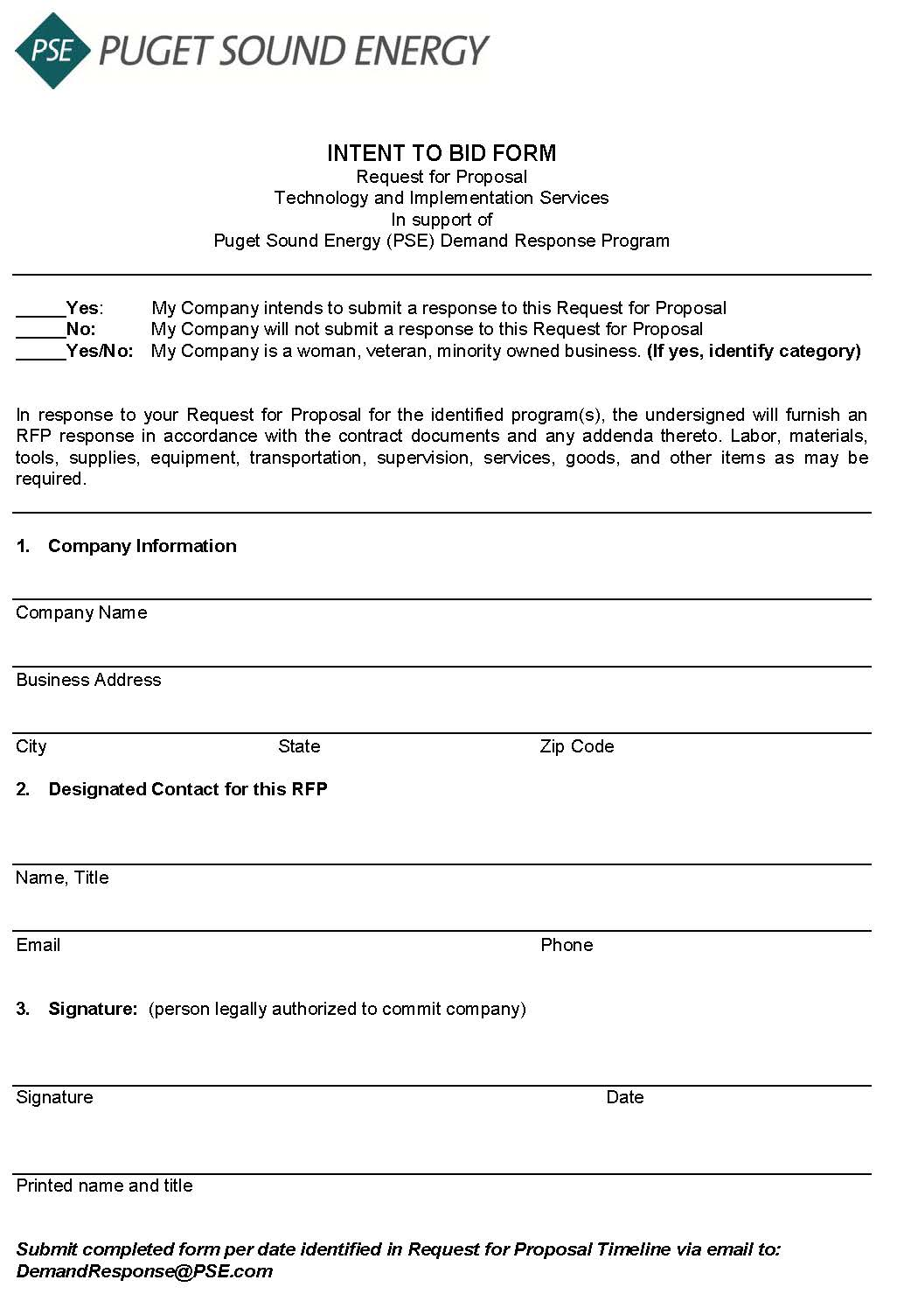

**Exhibit C: Mutual Nondisclosure Agreement**

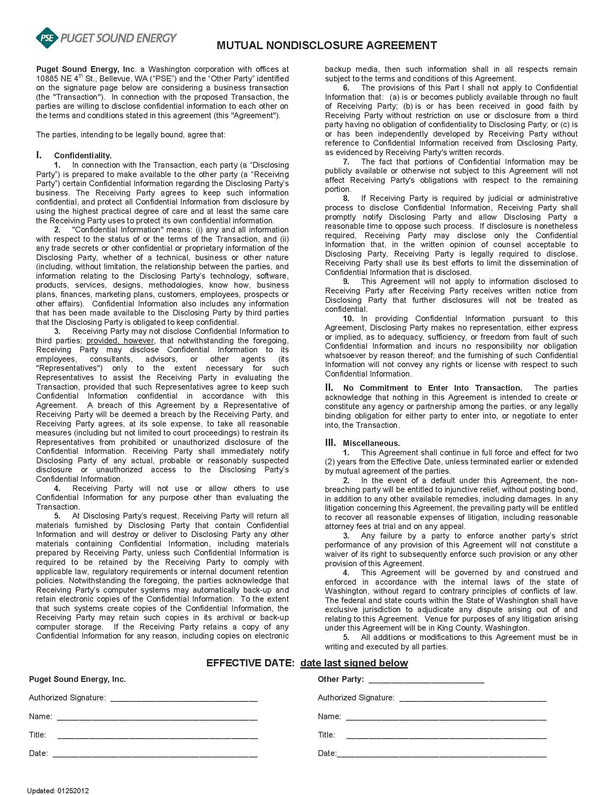

**Exhibit D: Cost-effectiveness Evaluation Criteria**

PSE prefers proposals that provide the lowest reasonable cost throughout the program or project life, taking into account the price of the proposal and other factors that impact PSE’s overall cost. PSE intends to analyze the cost-effectiveness of demand response proposals in a manner consistent with the IRP.

PSE will evaluate bids in two ways: using benefits and costs as indicated in the Program Administrator Cost Test (PAC) and Total Resource Cost (TRC) Test. The benefits and costs shown in the tables below will be included in the bid evaluation process when applicable, quantifiable, and significant. PSE prefers proposals and combinations of proposals that result in the lowest impact on PSE's revenue requirements and rates when included in PSE’s existing generation resource portfolio.

PSE will adjust the bidder’s proposed capacity during the evaluation process using Effective Load Carrying Capability (ELCC) as shown in Table 3. The ELCC used in this evaluation will be dependent on the bidder’s proposed resource availability, i.e., frequency and duration of events. For example, a proposal with a program with no more than one, 4-hour event per day will be evaluated with an ELCC of 58%, while a program with up to two, 3-hour events per day with 6 hours of recovery time between events will be evaluated with an ELCC of 77%.

|  |  |  |
| --- | --- | --- |
| Benefits | PAC | TRC |
| Avoided Capacity Costs | ✓ | ✓ |
| Avoided Energy Costs | ✓ | ✓ |
| Avoided Transmission & Distribution Costs | ✓ | ✓ |
| Avoided Environmental Compliance Costs | ✓ | ✓ |

Table 1. Cost-effectiveness Benefits for PAC and TRC Test

|  |  |  |
| --- | --- | --- |
| Costs | PAC | TRC |
| Program Administrator Expenses | ✓ | ✓ |
| Program Administrator Capital Costs | ✓ | ✓ |
| Financial Incentive to Participant | ✓ | 🗶 |
| DR Measure Cost: Program Administrator | ✓ | ✓ |
| DR Measure Cost: Participant Contribution | 🗶 | ✓ |
| Participant Transaction Costs | 🗶 | ✓ |
| Participant Value of Lost Service | 🗶 | ✓ |
| Increased Energy Consumption | ✓ | ✓ |
| Environmental Compliance Costs | ✓ | ✓ |

Table 2. Cost-effectiveness Costs for PAC and TRC Test

|  |  |  |  |  |  |  |
| --- | --- | --- | --- | --- | --- | --- |
| ELCC Estimates for Various DR Event Parameters | | | | | | |
| Event  Duration (Hours) | **Call Frequency** | | | | | |
| **Elapsed Hours After Last Event** | | | | | **Elapsed Hours Since Start of Last Event** |
| **4** | **6** | **8** | **12** | **24** | **24** |
| 2 | 63% | 61% | 57% | 49% |  |  |
| 3 | 80% | 77% | 77% | 59% |  |  |
| 4 | 90% | 85% | 80% | 65% | 53% | 58% |
| 5 | 94% | 89% | 84% | 68% | 55% |  |

Table 3. Effective Load Carrying Capability Based on Frequency and Duration of Demand Response Events

# ****Exhibit E: Demand Response Key Proposal Details****

|  |  |  |  |  |  |  |  |  |  |  |  |  |
| --- | --- | --- | --- | --- | --- | --- | --- | --- | --- | --- | --- | --- |
| **Key Proposal Inputs** | | | | | | | | | | | | |
| **Project Name** | **Developer** | **Technology** | **Technology Details** | **Project Term** | **DR Capacity (MW)** | **Pricing:  Capacity Charge $ /kw-yr** | **Pricing:  Customer Incentives $ /kw-yr** | **Any other costs? Such as start-up, annual operational, software and others?** | **Call frequency: Number of calls of resources per Winter Season** | **Call Duration** | **Elapsed Hours after last event** | **Program Readiness: Day Ahead / Hour Ahead/ 10-min Ready** |
| **Examples** | | | | | | | | | | | | |
| ABC | XYZ Inc. | Direct Load Control | Bring your own thermostat | 2023-2028 | 10  *If capacity varies by year, provide all details* | 100 / kW-yr  *if pricing varies by year, provide all details* | 50 / kW-yr  *if pricing varies by year, provide all details* | $10,000 per year | 10 calls | 2 hours | 4 hours | 10-min ready |

1. *Winter capacity for 2023 covers November 1, 2023 to February 29, 2024.*
2. *PSE has a legal obligation to meet the requirements of the Energy Independence Act, Chapter 19.285 RCW and the Clean Energy Transformation Act (“CETA”), Chapter 19.405 RCW. The Energy Independence Act requires PSE to acquire qualifying eligible renewable resources and/or renewable energy credits to meet 3 percent, 9 percent and 15 percent of its load by 2012, 2016 and 2020, respectively. CETA sets statewide policy goals for the elimination of coal‐fired resources by 2025, 80 percent carbon free generation and overall carbon neutral electricity by 2030, and 100 percent carbon free electricity by 2045.*
3. *In October 2019, the Washington Utilities and Transportation Commission Staff filed a Petition for Exemption from WAC 480‐ 100‐238 pursuant to WAC 480‐07‐100 until December 31, 2020. In November 2019, the WUTC held an open meeting concerning and other investor owned utilities in Washington) from WAC 480‐100-238. Pursuant to Order 2, PSE filed an IRP Progress Report on November 15, 2019.*
4. *Cost effectiveness criteria are discussed in Exhibit D.*
5. *PSE uses a daily forecast high below 40 degrees F and/or a forecast low below 30 degrees F to trigger a higher state of readiness for peak load. DR events can also be triggered at any time to address system emergency conditions within the program parameter constraints.*
6. *Note that PSE is responsible/accountable for hiring an independent third-party to perform the EM&V.*
7. *The specifications regarding the number and timing of the surveys/focus groups will be indicated at a later stage during/after the contract process.*
8. *Winter capacity for 2021 covers November 1, 2021 to February 28, 2022; winter capacity for 2025 covers November 1, 2025 to February 29, 2026*
9. *Note that loads will be dispatched according to the specifications outlined in Section 2.2 under Objectives.*
10. *This will need to be reconsidered/redefined for winter morning peak periods to which adjustments based on hours prior to the event period are invalid.*
11. *For a description of existing programs refer to PSE’s energy efficiency program information in PSE’s 2020-2021 Biennial Conservation Plan Exhibit 3, which contains EE program descriptions at* [*https://www.pse.com/-/media/Project/PSE/Portal/Rate-documents/EES/ees_2020_2021_biennial_conservation_plan.pdf*](https://www.pse.com/-/media/Project/PSE/Portal/Rate-documents/EES/ees_2020_2021_biennial_conservation_plan.pdf)