

2026 Gas Decarbonization
Request for Proposals

May 15, 2026



Table of Contents

Table of Contents 1
Acronyms and Definitions 2
1. Introduction 4
Overview 4
Regulatory Context 4
About Puget Sound Energy 5
About Carbon Direct 5
PSE Core Values 5
2. Proposal Eligibility 6
Eligibility requirements 6
Minimum criteria requirements 7
Interaction with existing PSE gas decarbonization projects and programs 9
Geographic targeting for electrification proposals 9
3. Schedule and Process 10
RFP schedule 10
Evaluation process 10
Independent evaluator 11
Negotiations and contracts 12
4. Proposal Requirements 13
Summary of Proposal Submission Requirements 13
Exhibit B: Proposal Form 14
Exhibit C: Bid Certification Form 14
Exhibit D Mutual Non-Disclosure Agreement 14
Code of conduct 15
Validity, deadlines and regulatory approval 15
5. Credit Requirements 17
6. Proposal Submission and Bidding Period 19
7. APPENDIX A: Geographically Targeted Electrification 20

Acronyms and Definitions

Term | Definition
Climate Commitment Act (CCA) | A 2021 Washington State law which established an economy-wide, comprehensive, market-based “Cap-and-Invest” program designed to incentivize greenhouse gas emissions reduction in Washington State through economic price signaling. Codified in RCW 70A.65.
CCUS | Carbon Capture Utilization and Storage
FERC | Federal Energy Regulatory Commission
Greenhouse gas (GHG) | As defined by RCW 70A.45.010: "greenhouse gas" and "greenhouse gases" include carbon dioxide, methane, nitrous oxide, hydrofluorocarbons, perfluorocarbons, sulfur hexafluoride, and any other gas or gases designated by the Washington Department of Ecology.
Highly Impacted Community (HIC) | As defined by WAC 480-100-605: A community designated by the department of health based on the cumulative impact analysis required by RCW 19.405.140 [Clean Energy Transformation Act] or a community located in census tracts that are fully or partially on “Indian country,” as defined in 18 U.S.C Sec. 1151. PSE’s service territory named communities are mapped here: https://esri.pse.com/portal/apps/mapviewer/index.html?webmap=da2b79bdd39847b4949683b10c7e2d81
Low-income (LI) | As defined by RCW 19.405.020(24) and WAC 194-40-030: Low-income means household incomes that do not exceed the higher of eighty percent of area median household income or two hundred percent of the federal poverty level, adjusted for household size.
Named communities/ named community | Overarching term covering “Highly Impacted Communities” and “Vulnerable Populations – High level.” Named communities in PSE’s service territory are mapped here: https://esri.pse.com/portal/apps/mapviewer/index.html?webmap=da2b79bdd39847b4949683b10c7e2d81
NWGA | Northwest Gas Association
PHMSA | Pipeline and Hazardous Materials Safety Administration
PSE | Puget Sound Energy
RCW | Revised Code of Washington
RFP | Request for Proposals
SCFH | Standard Cubic Feet per Hour
Small business (natural gas) | PSE defines a small business as a customer on gas Schedule 31 (and, if also taking electric service from PSE, a customer on electric Schedule 24 or Schedule 25) with a footprint of 10,000 square feet or less and with 50 or fewer employees at that premise.
Vulnerable Populations (VP) | As defined by RCW 19.405.020(40) and WAC 480-100-605: Communities that experience a disproportionate cumulative risk from environmental burdens due to (a) Adverse socioeconomic factors, including unemployment, high housing and transportation costs relative to income, access to food and health care, and linguistic isolation; and (b) Sensitivity factors, such as low birth weight and higher rates of hospitalization. PSE identified Vulnerable Populations through a methodology described in PSE's Clean Energy Implementation Plan and using feedback from PSE's Equity Advisory Group. PSE’s service territory named communities are mapped here: https://esri.pse.com/portal/apps/mapviewer/index.html?webmap=da2b79bdd39847b4949683b10c7e2d81.
WAC | Washington Administrative Code
WUTC | Washington Utilities and Transportation Commission

Introduction

Overview
Puget Sound Energy (“PSE”) is issuing this 2026 Gas Decarbonization Request for Proposals (the “2026 Gas Decarb RFP”) soliciting projects to reduce greenhouse gas (GHG) emissions from PSE’s natural gas distribution system.
The Gas Decarb RFP is available on PSE’s website at the following link: https://www.pse.com/pages/energy-supply/acquiring-energy/2026-Gas-Decarbonization-RFP.
PSE’s priorities for the Gas Decarb RFP are as follows:
  - Identify and fund projects that reduce emissions from PSE’s natural gas distribution system.
  - Reduce costs to PSE natural gas customers by reducing PSE’s natural gas Climate Commitment Act (CCA) compliance costs.
PSE will conduct a process that is accessible and fair for all respondents. PSE encourages all respondents able to meet the requirements of this RFP to participate, including respondents representing minority-, women-, disabled- and veteran-owned businesses as well as tribal groups.
This Gas Decarb RFP process may or may not result in one or more transactions by PSE. PSE has no obligation to enter into definitive agreements with any bidder to this Gas Decarb RFP and may terminate or modify the RFP at any time without liability or obligation to any bidder.

Regulatory Context
In 2021, the Washington State Legislature passed Senate Bill 5126, also known as the Climate Commitment Act (“CCA”), codified as RCW 70A.65. The CCA established an economy-wide market-based system “Cap-and-Invest Program” intended to reduce GHG emissions in Washington State that went into effect on January 1, 2023.
PSE is a covered entity under CCA that must acquire compliance instruments equal to GHG emissions from its electric and natural gas operations. As a natural gas utility, PSE receives no-cost allowances that must be consigned to auction for the benefit of ratepayers, deposited for compliance, or a combination of both.
This Gas Decarb RFP will be funded by revenue generated from the consignment of PSE’s CCA gas no-cost allowances at auction. The Washington Utilities and Transportation Commission (“WUTC”) approved an award amount up to a maximum of $40 million minus PSE’s costs to design the RFP, review proposals, and manage contracts over the lifetime of the selected project(s).

About Puget Sound Energy
Puget Sound Energy, a subsidiary of Puget Energy, is Washington State’s oldest local energy company, providing electric and natural gas service to homes and businesses primarily in the vibrant Puget Sound area. PSE serves approximately 1.24 million electric customers and nearly 900,000 natural gas customers in 10 counties. PSE meets the energy needs of its customers, in part, through cost-effective energy efficiency, procurement of sustainable energy resources, and far-sighted investment in the energy-delivery infrastructure.
Please visit the PSE website at www.pse.com for more detailed information. A service area map depicting PSE’s service coverage area as well as other pertinent company information may be found under the “Who We Are” tab.

About Carbon Direct
Carbon Direct is serving as the Independent Evaluator (“IE”) for this Gas Decarb RFP. Carbon Direct is a trusted energy and climate solutions company that combines world-class scientific expertise, technical rigor, and market insights to help clients achieve their business goals. Carbon Direct’s 70+ scientists work closely with their finance, policy, and market experts to design, diligence, and deliver decarbonization solutions across industries. From JPMorgan Chase to Microsoft, Carbon Direct helps leading companies with carbon dioxide removal, carbon measurement, firm clean power opportunities, and low-carbon energy solutions. To learn more, visit www.carbon-direct.com.

PSE Core Values
PSE is committed to its core values of safety, honesty, responsibility, and integrity and has specific expectations of entities with which we do business. As such, PSE expects all suppliers to comply with all applicable laws and regulations, such as those pertaining to the environment, safety and employment, discrimination, and labor laws. For more information, please review PSE’s Responsible Contractor Guidelines and Corporate Ethics and Compliance Code:
- PSE | Responsible supplier and contractor guidelines;
- http://www.pugetenergy.com/pages/codeethics.html

Proposal Eligibility
PSE will evaluate any technically viable proposal that complies with all applicable laws and regulations and meets the minimum proposal requirements described in this section. To address the requirements in this section, respondents will complete Section 1 (Eligibility) in Exhibit B.
PSE will accept responses from consortiums or multiple parties in partnership to complete a project. Proposals from consortiums or multiple parties must clearly identify the relationship (actual or proposed) among the parties for the purposes of a transaction with PSE, including the party (or parties) with whom PSE will have the contractual relationship.
PSE will not submit self-build or project proposals.
PSE is seeking projects that can be operational by December 31, 2028, but projects that are projected to be operational later should still apply and PSE will consider them in the evaluation.

Eligibility requirements
Proposed projects must meet the following eligibility requirements:
  - Per RCW 70A.65.130(2)(b), projects must directly reduce emissions from PSE’s natural gas delivery system. Projects that reduce emissions from PSE’s natural gas electric plants are not eligible. PSE is open to accepting any project that reduces emissions from its natural gas delivery system, including supply side or demand side projects. Projects may include but are not limited to energy efficiency measures, zero-emission fuel sources, increasing avoided cost or energy efficiency rebates for all customers or select customers.
  - Per RCW 70A.65.130(2)(b), projects must be those that PSE would not otherwise pursue under existing requirements in statute, rule, or other legal requirements. PSE will evaluate whether proposals would be pursued under existing requirements.
  - Per RCW 70A.65.130(2)(b), responsive proposals should minimize cost impacts on low-income, residential, and/or small business customers. This could include reducing PSE’s gas CCA compliance obligation or other cost savings. Please specify in your proposal.
  - Proposals that duplicate or conflict with existing PSE programs will not be considered. For example, PSE has a robust energy efficiency program. Energy efficiency services described in the following:
    - PSE rebates
    - PSE efficiency incentives for businesses
    - WUTC docket UT-250835, Exhibit 3 Program Details
  - Per RCW 80.86.070, projects must not include any form of rebate, incentive, or other inducement to residential natural gas customers to purchase any natural gas appliance or equipment (for example, a more efficient natural gas appliance). Exceptions in effect through January 1, 2031 include rebates and incentives for electric heat pumps that include natural gas backups and rebates and incentives for commercial and industrial gas customers.
  - Projects must be implemented with technology that is available, viable, and scalable.
PSE will not consider projects that use conceptual or speculative technology.

Minimum criteria requirements
PSE considers a variety of evaluation criteria when making procurement decisions, as described in Exhibit A: Evaluation Criteria and Scoring to this Gas Decarb RFP. PSE has also identified a set of minimum qualifying criteria to help respondents craft proposals designed to best meet the objectives of this solicitation. Proposals must meet the minimum criteria outlined below for consideration in this RFP.
  - Respondents must submit a complete proposal by the due date specified in the Gas Decarb RFP. PSE will not consider proposals that do not provide sufficient information to substantiate a project or offer.
  - All proposals shall state that the bidder currently owns or has legally binding rights to develop the project(s).
  - Each proposal (if applicable) shall acknowledge and state that PSE disclaims and shall not assume any risk associated with the potential expiration of (or the respondent's or other project entity's ability to utilize) any then applicable federal or state tax incentives, cash grant programs, or similar programs meant to support the proposal.
  - All proposals shall state that there will be no assignment of proposals during the evaluation or negotiation stage of this Gas Decarb RFP and that, in the event the respondent and PSE negotiate and execute definitive agreements based on the respondent’s proposal, the definitive agreements and obligations thereunder shall not be sold, transferred, or assigned, or pledged as security or collateral for any obligation, without the prior written permission of PSE. Any project lender who takes an assignment of the definitive agreements for security and exercises any rights under such agreements will be bound to perform such agreements to the same extent.
  - Proposals must include a plan to deliver greenhouse gas emissions reductions beginning on the targeted operational date. GHG emissions must be calculated in alignment with CCA compliance accounting standards.
  - All proposals must state that all environmental attributes associated with the project, if any, will accrue to the ownership of PSE.
  - All proposals must have a plan for complying with all applicable laws, regulations, published agency guidance, and executive orders, including environmental laws, state and deferral land use laws, and labor regulations such as any relevant prevailing wage regulations.
  - Respondents must certify they will adhere to all applicable safety laws, guidelines and industry practices. If a proposal is selected for funding, PSE reserves the right to review and assess at least the previous three (3) year safety performance of the respondent to ensure that they meet acceptable standards.
  - All electrical work must be performed by a licensed and bonded electrical contractor.
  - PSE will not accept credit requirements imposed on PSE by the respondent.
  - If appropriate, PSE will require credit support based on the bidder’s credit rating, consistent with Section 5 of the Gas Decarb RFP. PSE will require either a parental guaranty in a form acceptable to PSE, if the counterparty has an investment-grade credit rating (and meets other criteria), or the posting of security in the form of a letter of credit or equivalent bank guaranty. In addition, the acceptability of a parental guaranty is subject to aggregate limits on overall counterparty credit exposure. PSE will not provide credit support required by a bidder.
  - Proposal will certify that if selected for funding, the respondent will be responsible for meeting its scheduled deadlines. PSE will require the respondent to accept the risk and agree to pay liquidated damages for failing to meet contractual milestones, the terms of which will be discussed during contract negotiations. An example situation of liquidated damage restitution would be a respondent not achieving commercial operation by the agreed upon date and PSE collecting liquidated damages to cover the cost of procuring that lost capacity through other means. PSE may impose credit requirements based on the respondent’s credit rating.
  - Proposals must include sufficient detail to substantiate a viable project and to adequately assess risk.
  - If relevant, proposals must identify the geographical boundaries of the overall project by map, sketch, or drawing; depict all property ownerships within those boundaries on the map, sketch, or drawing; and provide real estate agreements demonstrating respondent’s degree of project site control for the purposes of the proposed project. PSE prefers proposals that provide complete copies of all real estate agreements demonstrating control, and independent third-party confirmation of property ownership such as title insurance commitments or policies for each property with copies of all exceptions. For property not under control for the project, PSE prefers proposals that include summaries of property owner contacts and the status of negotiations with those property owners.
  - If relevant, proposals must identify any required permits and approvals, and the status of each; and provide a schedule for completion as part of the overall project schedule. As discussed in Exhibit A: Evaluation Criteria and Scoring, PSE prefers proposals that further demonstrate a respondent’s permitting acumen (e.g., providing a permitting plan or demonstrating progress, identifying required studies and status, successful outreach to lead agencies and interested persons, indicating past success permitting other projects in the area).
  - The respondent has adequate protocols for handling any PSE customer data and cybersecurity measures consistent with PSE requirements.
  - Respondents must be willing to complete PSE’s IT Security screening form, which PSE will provide if warranted by respondent’s proposal.
  - If applicable, biomethane quality would meet Northwest Gas Association (NWGA) Quality Standard.
  - If applicable, the proposal would meet applicable Pipeline and Hazardous Materials Safety Administration (PHMSA) and Federal Energy Regulatory Commission (FERC) requirements for gas transmission and distribution lines.
  - Proposals from consortiums or multiple parties must clearly identify the relationship (actual or proposed) among the parties for the purposes of a transaction with PSE, including the party (or parties) with whom PSE will have the contractual relationship.

Interaction with existing PSE gas decarbonization projects and programs
For this RFP, PSE will consider each proposal in the context of its existing programs, listed below. Proposals that duplicate or conflict with existing PSE decarbonization programs may be referred to other programs and/or eliminated from consideration in this RFP process.
PSE’s existing programs that aim to reduce emissions from its natural gas delivery system include:
  - PSE Commercial Decarbonization Grant Program
  - PSE heat pump installation programs for low-income and named community customers funded by consignment of CCA gas no-cost allowances (“CCA Low-Income Decarbonization Programs”). These programs are meant for the benefit of residential low-income customers, multi-family premises with low-income residents or in named communities, or small business customers in named communities. For more information, see the most recent annual report available here.

Geographic targeting for electrification proposals
While not a requirement of proposals, PSE is interested in geographic areas where natural gas usage reductions have the potential to impact natural gas constraints or projects. See Appendix A for general geographic areas and natural gas reduction amounts of interest.

Schedule and Process

RFP schedule
The following schedule (Table 1) is subject to adjustment based on the actual pace of the evaluation process. Updates will be posted online at https://www.pse.com/pages/energy-supply/acquiring-energy/2026-Gas-Decarbonization-RFP.

Table 1. 2026 Gas Decarb RFP Schedule
Date | Milestone
May 15, 2026 | PSE issues final Gas Decarb RFP
June 8, 2026,  12pm Pacific | PSE hosts a bidders’ conference. PSE will post conference details and registration instructions on the Gas Decarb RFP website as they become available.
July 15, 2026  by 5pm Pacific | Offers due to PSE
Q3 2026 – Q4 2026 | PSE completes evaluation, selects final list of potential projects, and files final list with WUTC for approval. Respondents will be notified ahead of time about any delays.
Q4 2026 – Q1 2027 | Following UTC approval, PSE executes agreements for WUTC-approved proposal(s).

Evaluation process

Overview
The evaluation process will proceed through three phases. In the first phase, PSE will verify all proposals meet the minimum requirements described in Section 2 of this Gas Decarb RFP.
The second phase will involve in-depth review to identify a final list of potential projects according to Exhibit A: Evaluation Criteria and Scoring. PSE will follow a structured evaluation process designed to score and rank proposals based on an evaluation of costs, risks, and benefits. PSE will consider quantitative and qualitative factors to compare proposals with diverse attributes.
In the third phase, PSE will file the final list of potential projects with the WUTC, requesting approval to dedicate CCA gas no-cost allowance revenue prior to executing contract(s).

Phase 1: Intake process and screening
PSE’s evaluation process will begin with the intake of proposals via email. Respondents will download the RFP forms from PSE’s RFP website https://www.pse.com/pages/energy-supply/acquiring-energy/2026-Gas-Decarbonization-RFP and email the completed forms and attachments to PSEGasDecarbRFP2026@pse.com.
PSE will perform a preliminary screening to verify that proposals meet the minimum requirements. If a proposal is determined to be ineligible based on the screening, PSE will notify the respondent and the respondent will be given three business days to remedy the proposal (the “cure period”).
Proposals that fail to substantiate a viable project, lack credible detail, involve unacceptable risks or prohibitive costs, or otherwise fail to meet the minimum proposal requirements defined in Section 2 of the Gas Decarb RFP will not be further considered.

Phases 2 and 3: Comprehensive evaluation and WUTC filing
In the second phase, PSE will evaluate proposals according to the criteria in Exhibit A: Evaluation Criteria and Scoring. The evaluation team will combine quantitative and qualitative evaluation results to produce an individual score and ranking for each proposal.
The evaluation team may submit data requests to bidders to clarify proposal details or request further information about a proposal’s risks and benefits. For any potentially disqualifying discrepancy or failure to meet minimum requirements, the bidder will be given three business days (the “cure period”) to correct the matter prior to disqualification.
PSE will develop a shortlist of proposals that best align with its overall objectives. PSE may request interviews with shortlisted respondents.
Respondents will be given an opportunity to submit a best and final offer price. If no best and final offer price is submitted, the original bid price will be used.
PSE will then file the final list of potential projects with the WUTC and request WUTC approval to execute contract(s).
PSE may also hold in reserve a certain number of proposals, in the event that one or more of the selected proposals are subsequently withdrawn or eliminated for any reason, including unacceptable risks or fatal flaws identified during additional due diligence. PSE expects bidders to hold to their offer – should a bidder alter their offer PSE will re-evaluate and may discontinue negotiations.

Independent evaluator
PSE has retained Carbon Direct to provide independent evaluator (IE) services for this 2026 Gas Decarb RFP.
The function of the IE is to consult with PSE on the procurement activities in the 2026 Gas Decarb RFP as described below. The responsibilities and tasks of the Independent Evaluator will include the following:
- ensure that PSE’s Gas Decarb RFP process is conducted fairly, transparently, and properly;
- participate in the design of the Gas Decarb RFP;
- support PSE’s communications with potential bidders during the bidding period;
- support the bid evaluation process; and
- prepare a final report to the WUTC summarizing the RFP process and results. The report must:
  - Include an evaluation of the competitive bidding process including the adequacy of communication with stakeholders and bidders; and
  - Explain any ranking differences and why the IE and PSE were or were not able to reconcile the differences.
The IE will participate in meetings with the WUTC and PSE, on an as-needed basis, to discuss its findings. If called upon to testify, the IE may serve as an expert witness in proceedings.
The IE will be given reasonable access to information, meetings and communications related to offers submitted by all respondents. The IE will immediately report to PSE and the WUTC any perceived attempt by any individual or party to improperly influence any findings determined by the IE, or to challenge or interfere with their independent role in the solicitation process. See also Section 5 subsection “Code of conduct, eligibility and conflict of interest disclosure” for more information.
The IE will protect confidential respondent information consistent with the terms of the non-disclosure agreement included in the 2026 Gas Decarb RFP.

Negotiations and contracts
PSE may elect to negotiate price and non-price factors with any respondent whose proposal has been shortlisted. During negotiations, PSE will continue to update its economic and risk analysis as needed to reflect any additional or revised factors that may impact the total cost of a proposed project.
If a bidder alters their offer during negotiations, PSE may reevaluate the offer and suspend talks. PSE has no obligation to enter into definitive agreements with any respondent to this Gas Decarb RFP and may terminate or modify the Gas Decarb RFP at any time without liability or obligation to any respondent. This Gas Decarb RFP shall not be construed as preventing PSE from entering into any agreement that it deems appropriate at any time before, during, or after the Gas Decarb RFP process is complete. PSE reserves the right to negotiate only with those respondents and other parties who propose transactions that PSE believes, in its sole opinion, to have a reasonable likelihood of being executed substantially as proposed.

Proposal Requirements

Summary of Proposal Submission Requirements
Table 2 below lists required exhibits for proposal submission and exhibits for reference only. The primary proposal submission document is Exhibit B: Proposal Form. Proposal must include one complete copy of Exhibit B: Proposal Form and all required attachments (as indicated therein). Proposals must include one signed copy of Exhibit C: Bid Certification Form and Exhibit D: Mutual Non-Disclosure Agreement.

Table 2: Summary of Exhibits
Exhibit | Required  Submission | For Reference  Only / Optional
Exhibit A: Evaluation Criteria and Scoring |  | ✓
Exhibit B: Proposal Form | ✓
Exhibit C: Bid Certification Form | ✓
Exhibit D: Mutual Non-Disclosure Agreement | ✓
Exhibit E: Intent to Bid Form (Optional) |  | ✓
Exhibit F: Sample Information Security – Hosted |  | ✓
Exhibit G: Sample Information Security - Consultant |  | ✓
Exhibit H: CVs of key team members | ✓
Exhibit I: Corporate Safety Plan | ✓
Exhibit J: Financial records | ✓
Exhibit K: Project development schedule | ✓
Exhibit L: Customer Outreach & Engagement Plan | ✓
Exhibit M: Evidence of ownership or legally binding rights to develop the project (e.g., site control agreement, option, ownership documentation) | ✓
Exhibit N: Labor Plan | ✓
Exhibit O: Permit Checklist | If applicable
Exhibit P: Project Map/Service Area Map | If applicable
Exhibit Q: Deal Diagram | If applicable
Exhibit R: Documentation of other funding sources | If applicable
Exhibit S: PSE IT security screening form | If applicable

Exhibit B: Proposal Form
PSE expects respondents to provide complete information in their original submittals. PSE will not consider proposals that provide insufficient information to substantiate the project or offer. Minimum qualifying criteria are defined in Section 2.
All respondents must complete Exhibit B, including any required attachments identified therein, for each proposal submitted. Additional information, such as a cover letter or other attachments not specifically required in Exhibit B, may be provided as part of a respondent’s proposal and will be considered supplementary information to the required Exhibit B form.
Exhibit B shall be considered the primary proposal document. While it is the respondent’s responsibility to ensure that all information provided in Exhibit B is true and accurate, if PSE identifies an inconsistency between Exhibit B and other proposal contents, PSE will seek to clarify the discrepancy with the respondent with a data request. The respondent will be given three business (3) days to correct the discrepancy.
Exhibit B includes:
  - Proposal Form tabs
  - Lifecycle Assessment (LCA) worksheets
  - Cost Model Worksheet

Exhibit C: Bid Certification Form
Each proposal must include a copy of the Bid Certification Form (Exhibit C), signed by a duly authorized officer or agent of the respondent submitting the proposal. By signing the form, the respondent’s duly authorized officer or agent certifies that:
  - The respondent’s proposal is genuine; not made in the interest of, or on behalf of, any undisclosed person, firm, or corporation; and is submitted in conformity with any anti-competitive agreement or rules.
  - The respondent has not directly or indirectly induced or solicited any other respondent to submit a false or sham proposal.
  - The respondent has not solicited or induced any other person, firm, or corporation to refrain from proposing.
  - The respondent has not sought to obtain for itself any advantage over any other respondent by collusion.

Exhibit D Mutual Non-Disclosure Agreement
Each bid submittal shall include a signed and scanned copy of Exhibit D: Mutual Non-Disclosure Agreement. PSE will return one fully executed scanned Mutual Non-Disclosure Agreement to the respondent.
PSE must provide the IE with all data and information necessary to perform a thorough investigation of the bidding process and responsive bids. Additionally, PSE will retain all information pertinent to this Gas Decarb RFP process for a period of seven (7) years or until PSE concludes its next general gas rate case, whichever is later. Except to the extent required by law or regulatory order, PSE shall have no obligation under this Gas Decarb RFP to provide the models and data used in its evaluation process to respondents or other third parties.

Code of conduct
This Gas Decarb RFP will accept proposals from all third-party project developers, owners or other utilities that meet the minimum requirements and comply with the process guidelines described in this Gas Decarb RFP. All respondents shall disclose in their proposals any and all relationships between themselves, the project and/or members of their project team and PSE, its employees, officers, directors, subsidiaries, or affiliates.
PSE is committed to a culture of ownership, accountability, honesty, integrity and trust. In conducting this RFP, PSE will follow its Code of Conduct. This Code of Conduct outlines the honest and ethical manner in which all employees and boards of directors at Puget Energy, Inc., Puget Sound Energy, and related subsidiaries are expected to behave, with each employee having a duty to uphold the Code of Conduct.

Affiliate proposals
Affiliates of PSE will be eligible to submit proposals in response to this Gas Decarb RFP. Each respondent to PSE’s Gas Decarb RFP must disclose any affiliate relationship to PSE in Exhibit B.
All respondents, including affiliates of PSE, shall follow a consistent process for submittal. PSE will treat all respondents, including affiliates of PSE, in a fair and consistent manner throughout the evaluation. Consistent with PSE’s Code of Conduct, the Gas Decarb RFP evaluation team will neither give preferential treatment or special consideration to any affiliate of PSE to ensure no unfair advantage occurs, nor will PSE or its independent evaluator disclose the contents of its Gas Decarb RFP evaluation or competing proposals to affiliates of PSE prior to the information becoming publicly available. The IE will immediately report to PSE and the WUTC any perceived attempt by any individual or party to improperly influence any findings determined by the IE, or to challenge or interfere with their independent role in the solicitation process.

Validity, deadlines and regulatory approval

Bid validity and deadlines
PSE anticipates selecting a list of potential projects in Q3 2026. Unless a bid is withdrawn, PSE will assume that it is valid through completion of the RFP. Respondents must provide, or indicate their inability to provide, a proposal that includes firm pricing that remains valid through applicable management and regulatory approval, negotiation, and execution of definitive agreements. See Table 1: 2026 Gas Decarb RFP Schedule.

Regulatory approvals
Regulatory approvals for projects resulting from this Gas Decarb RFP may not be obtained until the latter half of 2026 or later. PSE will seek regulatory review of any acquisitions or associated costs that result from this RFP. Such regulatory review is expected to include receipt by PSE from the WUTC of approvals and orders, as applicable, pertaining to and confirming the inclusion of the full amount of any procurement price plus PSE’s transaction costs and other amounts allocable to the construction, start-up, testing, commissioning, and implementation of the project, as applicable. PSE will require that the substance and scope of any approvals or orders are in a form and substance satisfactory to PSE, in its sole discretion, prior to proceeding with any project.

Credit Requirements
PSE will not consider collateral thresholds, credit ratings triggers, generalized language asserting adequate assurances of performance, or similar language that might require PSE to provide performance assurance. PSE developed this policy to protect its customers and to avoid undue costs, especially in the event of an industry-triggered credit downgrade.
PSE requires respondents to provide performance assurance. PSE expects respondents with credit ratings below investment grade or those of similar creditworthiness, or whose credit ratings drop below investment grade, to provide performance assurance acceptable to PSE, typically in the form of collateral used to mitigate the risk of default. Non-investment grade entities have inherent default risks. Collateral requirements are utilized to mitigate such risks. This is consistent with standard industry practices.
PSE may require negative control provisions in any definitive agreements.
Financial Qualifications: Respondents must demonstrate financial capability to perform under the proposed contract through submission of the following:
Credit Documentation:
- Audited financial statements for the past three years
- Current interim financial statements
- Current credit ratings and reports from recognized rating agencies (if available)
- Bank references and credit facility documentation
- Cash flow projections for the contract term
- Debt service coverage and liquidity analysis
Corporate Structure:
- Articles of incorporation and corporate bylaws
- Ownership structure and beneficial ownership disclosure
- Parent company information and guarantees (if applicable)
- Subsidiary and affiliate relationships
- Material contracts and commitments
Performance History:
- Track record of similar project delivery and performance
- Customer references from comparable engagements
- Regulatory compliance history and any violations
- Litigation history and material legal proceedings
- Insurance claims history and risk management practices

Proposal Submission and Bidding Period
Please submit proposals via email to PSEGasDecarbRFP2026@pse.com.
Questions or comments about the 2026 Gas Decarb RFP may also be submitted to PSEGasDecarbRFP2026@pse.com.
PSE will post answers to questions as well as RFP schedule updates and any informational updates associated with this RFP to https://www.pse.com/pages/energy-supply/acquiring-energy/2026-Gas-Decarbonization-RFP. Potential bidders who would like to receive an email notification about such updates can complete an optional Intent to Bid form (Exhibit E).
PSE is committed to providing respondents with the guidance needed to successfully complete Exhibit B and to navigate the proposal submission process. PSE will not simply reject bids due to a data entry error or a misunderstood direction for a specific field. To help respondents successfully submit their proposals, PSE will provide the following:
  - An overview of the evaluation process at the bidders’ conference;
  - Unlimited access to submit and resubmit proposals during the RFP submission window, and;
  - A three-business-day cure period to allow respondents to remedy an unacceptable term or condition, or other non-conforming criteria or fatal flaw in a proposal.
Respondents should note that the bid submittal deadline is not subject to the three-business-day cure period. PSE expects respondents to submit bids on time, allowing sufficient time to seek advice from the Gas Decarb RFP team in the event of any data entry errors. Respondents are encouraged to submit early. Respondents will have until the due date to resubmit forms and other supporting files.

APPENDIX A: Geographically Targeted Electrification
The following locations and approximate reductions are of interest for geographically targeted electrification proposals.
Location 1: Peak Shaving
PSE gas customers located in zip codes: 98070, 98332, 98335.
To be able to impact an infrastructure project, approximately 300,000 Standard Cubic Feet per Hour (SCFH) would need to be reduced on a peak hour.
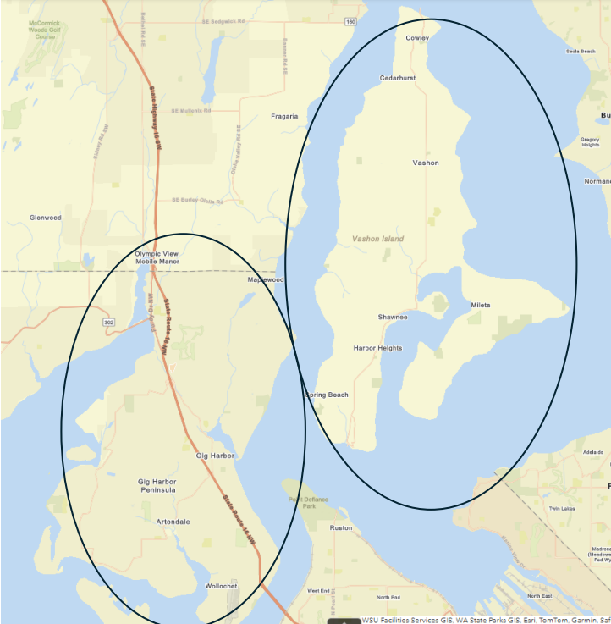

Location 2: Peak Shaving
PSE gas customers located in zip codes: 98102, 98104, 98109, 98112, 98119, 98121, 98122, 98134, 98154, 98174, 98199.
To be able to impact an infrastructure project, approximately 1,869,000 SCFH would need to be reduced on a peak hour by 2032.
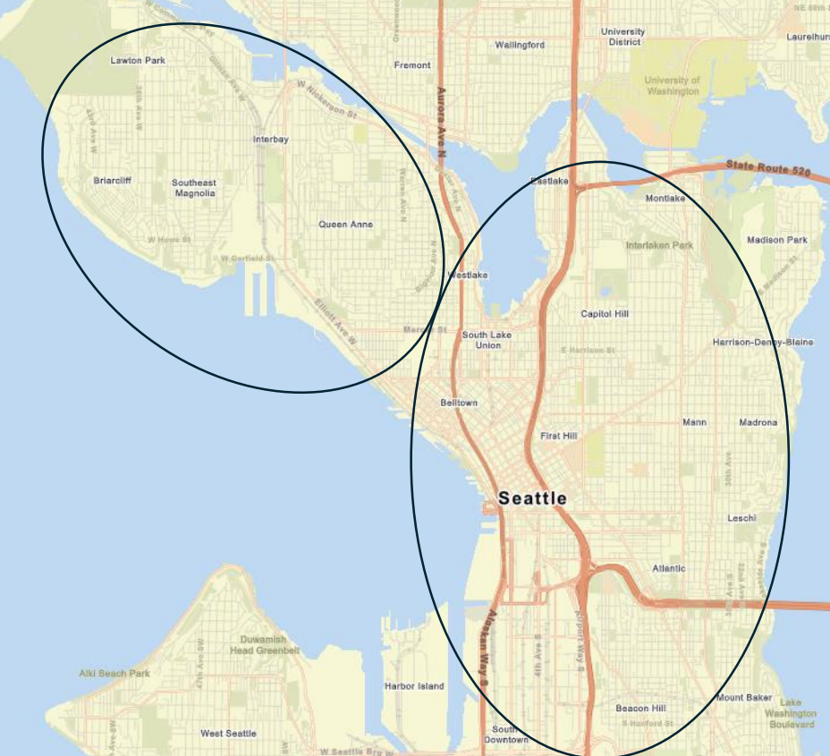

Location 3: Gas Removal
Specific addresses to be provided upon agreement and selection. All relevant customers’ end uses must be electrified and service to the location must be able to be retired to avoid potential investments.
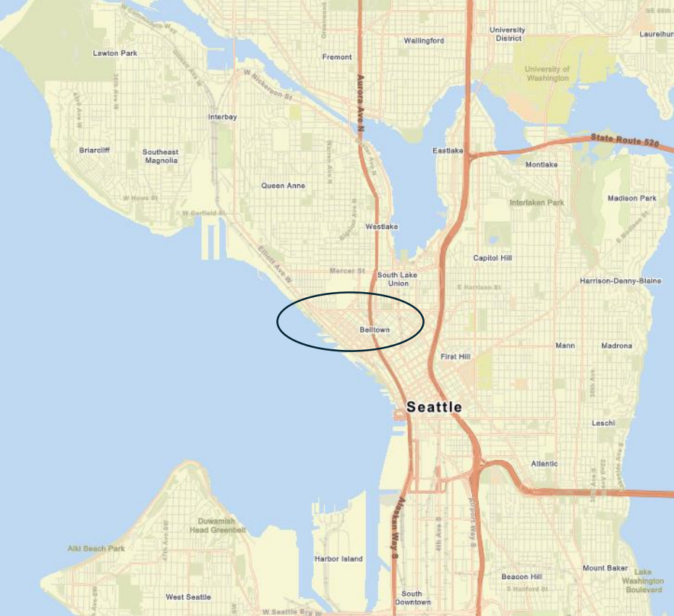

Puget Sound Energy Natural Gas Tariff Schedule 111, Docket UG-240884, filed December 3, 2024
Either allowances or offsets
RCW 70A.65.130
WUTC Order 01, Docket UG-250843, December 24, 2025 available at utc.wa.gov.
"Environmental attributes" means generally credits, benefits, reductions, offsets and other beneficial allowances with respect to fuel, emissions, air quality, or other environmental characteristics, resulting from the use of certain generation resources or the avoidance of emissions.
PSE’s 2026 CCA Decarbonization Programs Annual Report, Docket UG-240884, filed April 3, 2026.
“Negative control provisions” means covenants restricting respondent business practices that could jeopardize respondent’s ability to perform its obligations.

