Wild Horse Conference Room Amenities
Thank you for your interest in the Colockum Conference Room at the Wild Horse Renewable Energy Center. Please review this information in regards to conference room features and use.

Location
- The Renewable Energy Center (visitor center) is set high on a ridge, with incredible views of the Cascade Mountains and the Columbia Basin. The conference room is located at the back of the visitor center, and features 270 degree views, and an abundance of natural light.
- Parking: A gravel parking lot with space for 80 vehicles is located in front of the visitor center.
- Loading/Unloading: Vehicle access is allowed on the patio for unloading, EV charging, or for parking for visitors with limited mobility. Yield to pedestrians, and keep speed under 8mph.
Conference Room Features
- Free for community use. We do ask that you explore the exhibit area, or schedule a presentation or tour, to ensure that use of the space is also educational. No weddings or sales events.
- 85 inch TV screen connected to a computer for presentations, videos, and Wifi access. A wireless mouse and keyboard are provided.
- A microphone is available on the podium, and there is an additional hand held mic that can be passed around to participants if needed. Do not place in close proximity to the front speakers.
- Laptops can be connected to HDMI cable which connects to ports on either side of the screen.
- PressIT 360 Camera/Speaker: This conferencing camera can be plugged into a laptop for hybrid meetings. This is best used for small groups in a smaller seating configuration, as the camera and mic will not be able to pick up speakers in the corners of the room.
- Terra Cotta Wall: Please do not stick anything to the front wall. It will peel off the finish.
- WiFi: The PSE Café Guest WiFi password will be posted on the white board (it changes monthly). After entering the password, open internet browser/Google and click Accept. This is a corporate network. Certain file sharing sites will be blocked.
- The visitor center is open to the public. While you will be in a separate room, you will hear groups as they are coming and going in the exhibit area. Staff will enter the storage area and kitchen throughout the day to restock supplies.
Kitchen
- Full kitchen: Refrigerator, oven, range, microwave, ice maker, coffee maker, dishwasher, electric teapot, pots and pans, serving trays, utensils, salt and pepper shakers, and more. Feel free to utilize the kitchen for food prep and service.
- Plates, cups, mugs, and silverware may be used, but are limited to groups of 25 people or less. We encourage you to use our dishes rather than disposable items to minimize waste.
- We can provide free local D&M Coffee, hot water, ice water, and a selection of teas, creamer, coffee cups, and sugar. The coffee maker is tricky, so please let us know if you need more.
- A 5 ft. serving bar looks out from the kitchen into the conference area, and we can also set up additional tables for food service.
- Assorted coffee mugs are available in the cupboard next to the refrigerator.
- Site staff will also be using the kitchen to make coffee and tea, restock supplies, and prepare food. There is a pull down divider above the serving bar that can be utilized to separate the kitchen from the conference room to minimize sound if needed.
Room Setup
The room is set up with tables and chairs facing the front (classroom/theatre), for up to 36 people. We can seat up to 48, but some people will not be at a table. Tables can be rearranged into a horseshoe, conference/rectangle, or squares. Please let us know if you would like the seating layout diagrams.
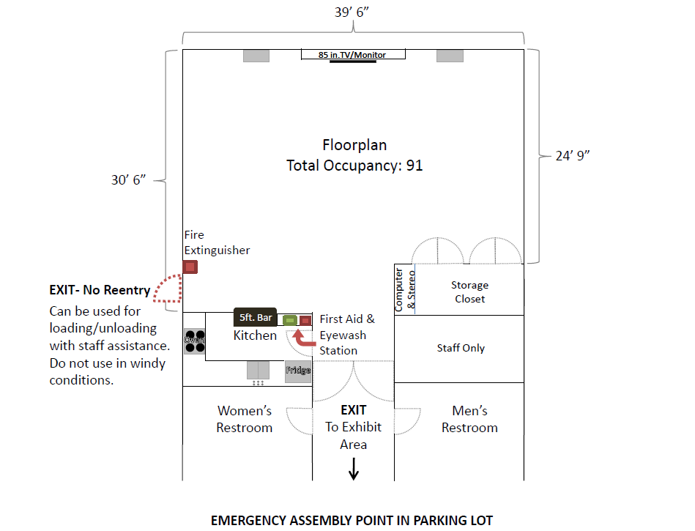

Additional Supplies
- Power Strips and Cord Covers: Some power strips are stored in the podium. Please ask staff for additional cords/power strips and cord covers. Please cover cords in walkways, and do not daisy chain/interconnect the power strips.
- EV Charging: Four NEMA 230v outlets are located on the east side of the conference room on the patio. Two outlets are equipped with Chargepoint J1772 and NACS options for Level 2 charging. Please request our EV charging document if you would like more information.
- There is a small white board and an easel with a paper pad on the two front tables. We have a few additional easels as well. Please request via email and we will set them out.
Food Service
Some local restaurants will deliver or cater on site, or may have options for pick up:
Catering Options
Local Restaurants | Contact | Info
Ellensburg Pasta Company | 509 933-3330 | Boxed lunches or catered entrees, pick up or delivery.
Cascade Mountain Grilling | 509 925-2951 | Catered entrees. Delivery.
Smokey’s BBQ | 509 925-4783 | Boxed lunches or catered entrees.
Fidelina’s | 509-962-2347 | Burrito or taco bar. Pick up only.
Lunchbox Cafe | 509-933-3332 | Boxed lunches. Pick up only.
Daily Bread | 509-925-2253 | Boxed lunches. Soup, sandwiches, & salads. Pick up.
Nomms | 509-420-5653 | Local delivery service.
Vinman’s Bakery | 509-933-1850 | Baked goods/breakfast pastries. Pick up only.
There are many food options in Ellensburg, but we have worked with these locations more frequently.
Clean up
- Our staff will be assisting you throughout the day. Please ask for assistance if you run out of coffee or other supplies, and for help during cleanup.
- Recycling Bin: Clean paper, aluminum cans, cardboard, and plastic bottles. No Food or Liquids.
- If you have additional garbage that will not fit in the trash cans, please take it with you. If that isn’t possible, let staff know and we will find a temporary home for it, as we do not have a dumpster at the visitor center.
- Any used dishes can be rinsed and placed in the dishwasher.
- There are rags in the bottom left drawer under the bar and cleaner underneath the sink. Please don’t use hand towels for cleanup.
Safety
- As noted in the room diagram above, there are two exits to the building, and the emergency muster point is in the parking lot. We will occasionally have comm. alarms in the locked room next to the conference room. Please let staff know, and we will silence the alarm. If the building alarms sound, please exit the building immediately.
- There is an eyewash station and first aid kit in the kitchen, fire extinguishers by both doors, and an AED at the front door. Ask staff for additional first aid supplies if needed.
- No access within 300 ft. of the turbines. For groups booking in the winter months, there is no access within 1,000 ft. of the turbines. If you would like to schedule a guided wind turbine tour during your visit, please let us know, and we will send you the tour rules and liability forms.
- Power may be interrupted when performing routine maintenance on the site substation. We will try to let you know in advance if this will be scheduled while you are utilizing the room.
- Weather: The visitor center and conference room will be closed during freezing precipitation. If the forecast looks concerning, we will notify you prior to your event. If conditions become unsafe overnight, we will have to cancel the day of your event. At 3,500 feet, the weather is quite different than the valley floor. Use this National Weather Service link to monitor the forecast.
- Roads: The visitor center is located up the winding Beacon Ridge Road, which gains 1,000 ft. of elevation in just 3 miles. The speed limit is 20-25 mph to protect visitors and wildlife. This private road is paved for just the first 3 miles to the visitor center.
Contact Info:
Renewable Energy Center Phone: 509-964-7815 (April - Oct. 31)
Wild Horse Wind & Solar Facility Phone: 509-964-7806 (Nov. - March)
25905 Vantage Highway Hours: 9:00 AM – 5:00 PM (April - Oct 31)
Ellensburg, WA 98926 Email: wildhorse@pse.com
Website: www.pse.com/wildhorse Facebook: www.facebook.com/wildhorseREC
Wild Horse is happy to be able to offer this conference space to community groups free of charge. We ask that you treat the space with respect, and leave it in the same condition as when you arrived. We do our best to keep it clean and well stocked, but please let us know if you have any issues or concerns.
Thank you,
Wild Horse Staff

