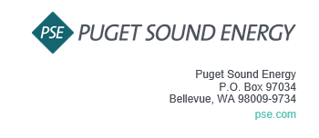
Notice of Customer Meeting for the 2026 Annual Update to the 2026 PSE OATT Formula Rate
Puget Sound Energy, Inc. (PSE) invites you to attend PSE’s Customer Meeting for the 2026 Annual Update to the PSE OATT Formula Rate. The Customer Meeting is an additional opportunity for Interested Parties to obtain information about the Annual Update.
The Customer Meeting is scheduled for July 16th, 2026 at 9:00 am PST. The meeting will be held via Microsoft Teams. The Teams information is as follows (Cntl+Click to follow the link):
Join on your computer, mobile app or room device
https://teams.microsoft.com/meet/264929831344392?p=L5x8fXRUQc1IegJ0sq
Meeting ID: 264 929 831 344 392
Passcode: Mn9rq6QN
Dial in by phone
+1 323-484-5815,,648377116# United States, Los Angeles
Find a local number
Phone conference ID: 648 377 116#
For organizers: Meeting options | Reset dial-in PIN

If you have any questions, please contact Lynn Dillender at lynn.dillender@pse.com.
Sincerely,
Puget Sound Energy, Inc.

Lynn Dillender
Regulatory Compliance Consultant

